**TAJIK NATIONAL UNIVERSITY**

**FINANCIAL AND ECONOMIC FACULTY**

**DEPARTMENT "FINANCE and INSURANCE"**

**IBROKHIMZODA ILKHOMUDDIN RAJABALI**

**ISMATOV ASADULLO KHURMATOVICH**

**SHARIPOV UMARJON AKHTAMOVICH**

СORPORATE PROJECT MANAGEMENT

**(For students majoring in economics)**

**Dushanbe -2022**

LIST OF MAIN ABBREVIATIONS

GG - general goal

ISD - initial structural division

BIP - break-even point

TR - terms of reference

NPV - net present value

ACWP - Actual cost of work performed

BAC - Budget Completion (the planned cost of the entire project)

ВCWP— budgeted cost of work performed

CAPM Certified Associate in Project Management

CPI - Cost Performance Index

CCPI- Cumulative CPI (cumulative index of budget execution)

EAC -Estimate at Completion (estimate of the cost of the project at completion) ETC- Estimate to Completion (estimate of the cost of the remaining part of the project)

EV - Earned Value (achieved volume)

EVA - Earned Value Analysis

PB - Payback period

PERT - Program Evaluation and Review Technique (a method for evaluating and revising the plan)

PMBOK - Project Management Body of Knowledge (professional knowledge of project management)

PMI - Project Management Institute

PMP - Project Management Professional

PV - Planned Value (planned volume, planned cost of planned work)

SPI - Schedule Performance Index

WBS - Work Breakdown Structure

TOPIC 1. THEORETICAL FOUNDATIONS OF PROJECT ACTIVITIES

* 1. Introduction on project management
  2. Background of project management

1.1. Introduction and background of project management

In the aggregate of its institutional subsystems, project management was institutionalized only by the end of the 20th century, but had a rather interesting background. Management as a science and practice of management entirely fits into the historical socio-cultural context, moreover, it is determined by it. Classical schools of management arise in the era of mass industrial production (late 19th - first half of the 20th century). Their methodology is formed on the basis of the systematization of practical experience and is based on rational models of both organizational structures (for example, the bureaucratic model of M. Weber) and their management processes (A. Fayol's theory of general administration). In this rational organizational and managerial paradigm, the organization is considered exclusively as an object of management practice, and management itself is seen as a process of influencing the internal environment of the organization, streamlining the elements of the organizational system. Management methods are also purely rational in nature: specialization, formalization, regulation, etc.

The modern stage in theoretical management begins in the second half of the 20th century. This is a time of post-war changes associated with the rapid flourishing of the service sector. In a dynamic economic market, a huge number of small and medium-sized organizations are emerging with small target audiences with situational consumer demand and behavior. Neither management theories nor organizational theories formed by that time had universal recipes for managing large, medium and small businesses. The methodological crisis of management leads to the formation of two new directions: systemic and situational approaches. Modern concepts of management are based on a probabilistic-rational (situational) organizational and managerial paradigm. the organization qualifies as an open system, a kind of black box (it is known that at the input and output, nothing more), inside which synergistic effects of various modalities reign, for which non-linear development is highly characteristic. As a result, actual project management integrates the methodological postulates of system analysis and synergetic theory. Thus, the project technology is a product of the current paradigm of culture, the practical development of management and the result of the current level of scientific management knowledge.

Modern management principles require collective approaches to the fulfillment of the tasks set for organizations. One of the most effective and advanced management principles today is project management. the use of the principles of project management allows you to more effectively solve the problems of the development of the organization, increases the reliability of the successful achievement of goals in all types of activities.

* 1. Background of project management

Project management is a separate independent area of ​​management that was formed and institutionalized in the middle of the 20th century. As a specific management activity, localized in time, having a unique specific result. Historically, project management has been taking shape since the beginning of the last century, growing out of the purely practical needs of a developing industry, primarily military, in the United States. Initially, individual tools and subsystems of the project begin to be used in planning practice, in particular, the network planning methodology, the Gantt chart, etc. Subsequently, all aspects of project management are formalized, a theory is developed, considered primarily as an applied technological paradigm created to achieve the set goal in conditions of limitedness of all resource components and allowing to achieve the optimal use of these resources.

In 1969, the Project Management Institute (PMI - Project Management Institute) began its work in the USA - an international non-profit association of specialists in the field of project management, uniting more than 150 countries. PMI was created to provide information and technology support to professionals in the field of project management. its activities are related to the development of standards in this area, research and educational activities, the implementation of professional certification. professional certification is carried out to obtain the PMP (Project Management Professional) and CAPM (Certified Associate in Project Management) degrees.

By 1987, project management had become a separate discipline, and PMI developed the first edition of the international PMBOK standard. To date, several Institute standards have been developed that describe various aspects of project management.

The main standard - ANSI PMI PMBOK Guide 3 Edition, 2004 - defines the subject of project management and basic concepts: project, project life cycle, project management essence, project phases and stages, main project participants, describes 9 project management knowledge areas, 5 management process groups projects, 44 project management processes. The characteristic of each process includes the initial input data, methods, tools and output data. The standard gives a holistic systemic picture of a separate area of ​​management - project management.

Other standards describe specific aspects of project management:

• PMI Practice Standard for Work Breakdown Structures - a practical standard for the hierarchical structure of the project;

• Project Manager Competency Development Framework - a guide to assessing and developing the professional skills of project managers;

• Organizational Project Management Maturity Model - The standard for project management maturity.

Before any organization and any project manager, sooner or later, the question arises of the need to adhere to standards in their daily activities. Can standardization be avoided? practice shows that any organization can do without any recommendations, creating its own approach, acting by the “trial and error” method in order to come to the realization of the simplest truth after a series of unsuccessful projects. it is not worth reinventing the wheel at the cost of a huge useless waste of resources, it is better to study and comply with standards in which colossal world experience has been accumulated.

Design is universal both in an extensive (objective) and intensive (instrumental) sense. Today, design technologies are used in industrial production, construction, architecture, design, politics, culture, education, and the social sphere.

From a professional point of view, design is institutionalized and constituted in management specialties. Designing as an intellectually and socioculturally independent type of activity is aimed at creating new real objects with given qualities. As a social institution, design launches the socio-cultural mechanism that turns any culturally significant activity and the values ​​it generates into tangible technological processes and structures. On the other hand, the project fits into the paradigm of contemporary culture and reflects the contemporary socio-cultural context. The specificity of the culture in which the social subject is inscribed is assimilated by him in the products of the project.

Any project is always a complex task. The fundamental complexity of the project task determines a new style of management activity, in which socio-cultural, technical, technological, organizational and managerial aspects interact and complement each other. in terms of design, not only the object is seen, but the entire system of connections around the future object. the area of ​​existence of truly systemic problems and systemic objects is the area of ​​systemic methodology that allows deploying such a representation of an object in models and ontology so that it then explains different subject representations and depicts them in the form of its projections.

This manual is the basis for the formation of the transprofessional status of the project culture, which predetermines the transition of management activities to a higher level of theoretical understanding and practical implementation.

Each of the selected design objects has a certain specificity, certain features. when designing, it is important to identify the patterns characteristic of a given type of object, using special techniques along with general principles and approaches.

Among the characteristics of design, a special place is occupied by the conditions of project activities or the design background. This is a set of conditions external to the design object that significantly affect its functioning and development. It is about the need to take into account local conditions. some possibilities, alternatives can be realized, but some not - it depends on local conditions, project environment, external constraints.

The purpose of design is to develop a certain future state of the system, processes, relationships.

means - a set of techniques and operations to achieve a goal. in general terms, the design tools can be defined as all that, with the help of which it is obtained, is analyzed information about the state of processes and their development trends. here are also the means by which direct design is carried out, verbal descriptions, tables, diagrams, networks of interactions are created.

Methods are ways and means of achieving goals and solving problems. In design practice, the most commonly used methods are brainstorming, peer review, analogy, network planning, scheduling, structural decomposition, simulation, resource planning, etc.

Within the framework of the project, methods and means are specified by a set of planned activities. Practical measures determine the directions, forms and content of activities, attract additional resources necessary to achieve the goals of each stage. Measures can be aimed directly at solving the problem, or they may be necessary for their financial support (auctions, paid services), for the formation of a favorable public opinion of the population through the media.

TOPIC 2. DEFINITION OF THE PROJECT AND ELEMENTS OF PROJECT ACTIVITIES

2.1. Definition of the project, its main characteristics and measurements

2.2. Elements of project activities

2.1. Project definition. Its main characteristics and measurements

Project (from the English project - something that is conceived and planned). In the modern literature on project management, two main approaches to the definition of the project can be distinguished: system and activity.

The system approach defines a project as a system of temporary actions aimed at achieving a unique, but at the same time certain result. “A project is a temporary venture to create unique products, services, or results.”[1] A systematic approach to the definition of the project predetermines its main characteristics. projects can be varied and multifaceted. However, they all share the following common characteristics:

- one-time - all projects are a one-time phenomenon. They come and go, appear and disappear, leaving behind concrete results that differ significantly from our daily duties and activities;

— uniqueness — no two projects are the same. each of them, regardless of its results, basically has something unique, characteristic only for it;

- innovativeness - in the process of project implementation, something new is always created. changes can be big or small;

- effectiveness - all projects have well-defined results. It could be a new house, a printed book, a modified company structure, an election victory. all projects are aimed at obtaining certain results, in other words, they are aimed at achieving goals;

- temporary localization - all projects are limited by clear time frames. a project is the creation of something by a set deadline, it has a planned completion date, after which the design team is dissolved.

all of the above characteristics are interrelated and define the specific scope of the project, its three dimensions, the criteria by which any project can be evaluated (Fig. 1.1).

TERMS

OUTCOMES

COST

**Figure 1.1. Project measurement scheme**

The planning and implementation of a project is always associated with three main questions:

- how long it will take;

- how much it will cost;

- whether the final result will coincide with what we planned at the beginning.

The first question brings to the fore the problem of the time frame set for the implementation of the entire project and its individual stages. The second question draws our attention to the cost of the project, the third concerns the question of the effectiveness of the project activities.

The versatility and multidimensionality of the design technology is determined by multi-level multi-layered interactions and dimensions of the project. project dimensions - goals, time, cost - are at the same time project constraints that define the coordinate system in which the project manager is forced to work. The super-task of the project manager is to find the optimal ratio of these three project constraints, with which the interests of the project participants are inextricably linked. In this sense, the most important task is transformed into maintaining a balance of interests; as such, restrictions become the "background", the "second plan" of action in the project, in which the title role belongs precisely to interests. In terms of dimensions and interests, all subsystems of the project can be explored.

The second approach, the activity approach, interprets the project as the activity of the subject to transfer the object from the current state to the state of the desired future, which most fully corresponds to his ideas. Thus, the project in the broadest sense can be understood as a creative, reasonable, goal-setting activity of the subject.

The essence of any project is activity. taking into account the definitions of the project, it is possible to define the project activity, or design. The term "projection" comes from the Latin projectus, a projection thrown forward. Projection is the transfer of the social subjectivity of the present into the future. the possibility of projection is due to the specific ability of a person to advance reflection and reasonable, conscious goal-setting. Social projection is the transfer to the future of one's feelings, preferences, desires, ideas. Thus, design is the process of creating a prototype, a prototype of a proposed or possible object or state. the designer, as it were, chooses from a variety of ways, versions of the development of the object, exactly the one that corresponds to the maximum extent to the scale of his values, preferences, ideas. The project activity has a dual character. On the one hand, this activity is ideal, since it is connected with planning for the future, foreseeing what should be. On the other hand, project activity is a technological activity, since it reflects the processes of implementing what is planned.

In order to accurately comprehend the essence of design, it is necessary to correlate it with concepts that are close in meaning and meaning, such as forecasting, planning, design.

Forecasting is a form of foresight, a conjectural assessment of the future state of an object, the conditions for its occurrence. Foresight is carried out using the methods of extrapolation, modeling, examination. The forecast serves as the basis for formulating development goals and strategies for achieving them. Any design related to foreseeing the future, one way or another, includes elements of predicting the future state of an object.

Planning is a scientific and practical justification for setting goals, identifying tasks, deadlines, rates, proportions for the development of a particular phenomenon, and its implementation. the plan has detailed goals, methods of activity, results. for a modern manager and businessman, a project is a means of planning and determining the main directions for the optimal use of the organization's resources. planning is always based on a certain program of action, which includes a set of conceptual targets. This is the difference between a program and a project. the program only indicates, works out the necessary set, a set of necessary areas of activity, indicates the desired final goals and results, the effectiveness of achieving these goals. the project, unlike the program, precisely calculates the ways of deploying activities to implement the program goals in the spatio-temporal continuum, designating in detail both small intermediate goals (summary tasks) and real actions (the tasks themselves). It is this precise study of the final actions necessary to achieve the main targets of the program that makes it possible to plan and predict with a high degree of accuracy all the parameters of the activities for the implementation of the program: terms, tangible and intangible resources, methods of communication, etc. We can say that the project is this is further detailing, deepening and concretization of program settings.

Construction is an intellectual activity consisting in the purposeful construction of an object in an ideal form. It is carried out through the mental combination of various factors, their selection and linking into a new object. Depending on the vision of the future, the designer corrects the present, introduces some innovations, constructing the desired state.

Design in addition to design, forecasting, planning, modeling is closely related to the technology of project implementation. a social project must have well-thought-out instrumental support. This makes it possible to avoid turning projects into utopias, replacing them with social manifestations or social fantasies, projects.

**2.2. Elements of project activities**

The main elements of design activity are the subject and object of design, its purpose, technology (as a set of operations), means, methods and design conditions. the subject of design is always various carriers of managerial activity - both individuals and organizations, teams, social institutions that set their

purpose of transforming reality.

In addition to design subjects, participants in the development and implementation of the content of projects (especially at the stage of its implementation) can and should be:

- decision-making bodies, whose functions are related to the provision of projects, their approval, control over their implementation;

— state and non-state organizations, scientific and expert councils capable of taking responsibility for the development, justification, examination of projects, capable of attracting the attention of the population, the media to projects;

— the public grouped around specific programs and projects.

Design objects can be[2]:

— objects of material nature (for example, the design object may be the construction of a new administrative building or the creation of a new computer); as a result of the implementation of the project, a new object, thing, object appears; at the same time, new properties can be projected - the purposes and functions of the old thing; such objects are more often associated with technical design;

- intangible (non-material) properties and relationships (for example, there are projects that are not aimed at achieving a material result, but at obtaining information about customers, changing our attitude to a particular problem). Such projects are called "influence projects". examples are:

- advertising campaigns;

- processes (for example, designing impact systems - ideologies, education systems, etc. in these systems, the ideological design is also important - the concept and appropriate tools for introducing ideas into people's minds. There is a wide scope for developing appropriate social technologies, designing new communication channels , standard algorithmic elements of activity, etc.);

- services;

- organizations and structural divisions (within the framework of the design of organizations, ideas of various scales are implemented - for example, social service institutions, industries, management, etc. are being designed);

- events (actions) (preparation of events can be carried out using project methods. This primarily applies to mass events - sports, festive, public, etc.);

- bills.

Each of the selected design objects has a certain specificity, certain features. when designing, it is important to identify the patterns that are characteristic of this type of objects, using special techniques along with general principles and approaches.

Among the design characteristics, a special place is occupied by the conditions of project activity or the design background. This is a set of conditions external to the design object that significantly affect its functioning and development. It is about the need to take into account local conditions. some possibilities, alternatives can be implemented, and some can not - it depends on local conditions, the project environment, external constraints.

The purpose of design is the development of a certain future state of the system, processes, relationships.

Means - a set of techniques and operations to achieve the goal. in general terms, design tools can be defined as everything that is used to obtain, analyze information about the state of processes and trends in their development. This also includes the means by which direct design is carried out, verbal descriptions, tables, diagrams, networks of interactions are created.

Methods are ways and means of achieving goals and solving problems. In design practice, the most commonly used methods are brainstorming, peer review, analogy, network planning, scheduling, structural decomposition, simulation, resource planning, etc.

Within the framework of the project, methods and means are specified by a set of planned activities. Practical measures determine the directions, forms and content of activities, attract additional resources necessary to achieve the goals of each stage. Activities may be aimed directly at solving the problem, or may be necessary for their financial support (auctions, paid services), to form a favorable public opinion of the population through the media.

TOPIC 3. CLASSIFICATION OF PROJECTS

Project management methods depend on the scale of the project, timing of implementation, quality, resource constraints, location and conditions of implementation. All these factors are the basis for identifying different types of projects, their classification:

1) in scale - micro-project, small, medium, megaproject:

- a micro-project is most often a form of presenting an individual initiative that has received recognition from others. The micro-project is being done for oneself and for our own people. it may not require external funding, special equipment, it may be created from improvised funds;

- small projects are small in scale, simple and limited in scope. Thus, in American practice, small projects are associated with an investment of 10-15 million dollars, labor costs of up to 40-50 thousand people. A typical example of a small project is the modernization of existing production facilities. the specificity of small projects is that they allow for some simplification in the design and implementation procedure (simple schedule, the leader is one person, it is not necessary to create a project team, etc.);

- medium projects are the most common in practice. they have a relatively short duration - 2–5 years, require a more thorough study of all project subsystems and involve more significant costs;

- megaprojects are targeted programs containing many interrelated projects united by a common goal, allocated resources, allotted time. Megaprojects have a high cost - up to 1 billion dollars, labor intensity - up to 2 million people, duration of implementation - 5-7 years;

2) in terms of complexity - simple, organizationally complex, technically complex, resource complex, complex complex;

3) by terms of implementation - short-term, medium and long-term. short-term projects require about a year, maximum two, for their implementation, short-term projects are usually implemented at enterprises for the production of new products of various kinds, pilot installations, and restoration work. commercial projects are often short-term. medium-term projects are carried out in 3-5 years. the duration of the implementation of long-term projects is 10-15 years;

4) in terms of quality requirements and methods of ensuring it - defect-free, modular, standard. defect-free projects are aimed at improving the quality of products or services; modular - for quality assurance in a certain direction;

5) according to the level of participants - international, domestic, state, territorial, local;

6) by the nature of the projected changes, projects are divided into innovative and supporting (resuscitation, restoration). the task of innovative projects is the introduction of fundamentally new developments. the main goal of supporting projects is to preserve the status quo. supporting projects, in turn, can be divided into anti-crisis, emergency, reform project, restructuring project;

7) by spheres and areas of activity - construction, engineering, financial, research (marketing), technical, technical and economic, consulting, scientific and technical, environmental, social, political, etc .;

8) by target - prestige projects and projects of influence;

9) by the specifics of financing - investment (the main motive of the investor is making a profit), sponsorship (the sponsor provides funds to support the project, if it can become a form of its advertising or presentation, to form the image of the company), credit (obtaining funds is possible only if guarantees to a credit institution, therefore, a loan project involves a detailed financial and economic justification), budget (funding sources - budgets of various levels), charitable (as a rule, these are non-profitable and costly projects, financing of such projects takes the form of patronage, grant form);

10) in terms of resources expended and profit received - commercial (making a profit), social (achieving social goals). on the basis of the prevailing focus, social projects can be: information and educational, training, rehabilitation (psychological, socio-psychological, labor rehabilitation), physical culture, artistic and creative, cultural;

11) pseudo-projects - a special group of projects that creates the appearance of a project, a form that covers some other content that is not presented in the project itself. there are two types of pseudo-projects - fiction projects and quasi-projects:

- fictional projects use the design form as a disguise (from the Latin Fictio - invention, concept) - these can be pseudo-projects like Ostap Bender's “horns and hooves” firm, when there is fiction already at the concept stage. It can be a kind and decoration of the activity - the image of the positive results of the project where they have not been achieved. since the 18th century. to designate such scams, the name "Potemkin village" began to be used;

- quasi-projects (the Latin prefix quasi means “as if”) is something that has the characteristics of a real project, but plans an innovation, which in fact is not.

**TOPIC 4. CONTENT AND PROJECT MANAGEMENT PROCESSES**

4.1. Project management tasks

4.2. Differences between project management and general management

**4.1. Project management tasks**

The essence of any project is activity, but in order for it to be successful, careful and thoughtful management of this project is necessary, which serves as a guarantee of effective activity, its focus on achieving the ultimate goal. project management is a methodology, art of organization, planning, leadership, coordination of labor, financial, material and technical resources throughout the entire project cycle, aimed at achieving its goals through the use of modern methods, techniques and management technology to obtain the compositional results defined in the project and the scope of work, cost, time, quality and satisfaction of the project participants.

project management tasks:

- determine the goals of the project and conduct its justification;

- to identify the structure of the project (sub-goals, main stages of work to be performed);

- determine the required amount and sources of funding;

- select performers and form a team of designers;

- prepare and conclude contracts;

- determine the terms of the project, draw up a schedule for its implementation;

- calculate the required resources;

- calculate the estimate and budget of the project;

- plan and take into account risks;

- to provide control over the progress of the project and much more.

The project management framework provides a framework for understanding project management and includes the following large sections:

1) the content of project management - a description of the environment in which the project operates, as well as its life cycle;

2) the project management process - describes a general view of how the various project management processes interact, how the various institutional subsystems of the project are managed:

- project concept management - concept initiation and planning. development of the project strategy, its refinement and control;

- management of the integration (content) of the project - its planning, development of the target structure;

- time management - planning of works, their sequence and duration, scheduling and scheduling;

- financial management (cost) of the project - development of estimates and budget of the project and cost control;

- quality management - planning and quality control of design work and project products;

- team management - describes the processes of effective use of human resources;

- project communications management - communications planning, information distribution, reporting;

- risk management - identification and management of project risks;

- project support management - describes the processes required to obtain goods and services for the implementation of the project from the outside. This is the planning of requirements: calls, selection of sources, development and closing of contracts.

Both sections of the structure are interconnected. All processes are declared at the pre-investment phase of the project, in its justification (business plan) and are implemented at various stages of the project life cycle.

**4.2. Differences between project management and general management**

General and functional management and project management

in terms of functionality (this can be seen from the definition of project management) they are identical. however, there are also differences between them. the differences between project management and general and functional management stem from the differences between the functions of project managers and the responsibilities of functional managers. These differences are presented in table. 1.1.

Table 1.1

**Differences between project management and general management**

|  |  |
| --- | --- |
| General management | Project management |
| Organizes the execution of a number of stable functions Organizes the execution of a number of stable functions  manages a permanent division  manages a relatively stable team of employees  As a rule, a subordinate group of specialists of one or related specialties understands the subject area better than their subordinates.  Stable in his position  Strives to make a "vertical" career, occupying higher and higher positions in his functional area the main part of motivation is a stable fixed salary | has a unique, clearly defined and detailed goal in each project  manages a project whose existence is limited in time  manages a temporary team, the composition of which may change during the course of the project, the participants may have dual reporting: to the project manager and their functional leader, usually a multidisciplinary team is subordinate  May not be an expert in the subject area of the project  At the end of each project, the career may turn out to be “temporarily unemployed”, the career is mostly “horizontal”, growth consists in the management of more and more complex, large-scale projects, the main motivation is a bonus depending on the result of the project |

In other words, the main difference between project management and general management is the balance between innovation and routine. Project management - management of changes, innovations. Any innovation is organized (should be implemented) in the form of a project, a specific technology. At the same time, the functions of project management include the following elements of general management:

- financial management - ensuring budgetary and other restrictions;

- personnel management - determination of the professional staff, management apparatus, motivation and remuneration system;

- operational (production) management;

- logistics - procurement and supply, determination of needs, selection of suppliers;

- engineering and quality management;

- marketing - from the pre-investment phase to the completion of the project.

**TOPIC 5. TECHNOLOGY OF PROJECT ACTIVITY**

5.1. Life cycle of the project,

5.2. Main stages of the project

**5.1. Life cycle of the project**,

The life cycle of a project is a set of all stages of project activity.

When developing a project, several phases (stages, steps) are usually distinguished to provide better management control. All phases in total make up the life cycle of the project (by analogy with marketing, the life cycle of a product). There are many different theoretical and practical versions of structuring the project cycle. analysis of literature and practical activities shows that there is no universal approach to dividing the process of project implementation into phases. When solving such a problem for themselves, project managers should be guided by their role in the project, experience, and specific conditions for the implementation of the project. Therefore, in practice, the division of the project into phases can be very diverse, as long as such a division reveals some important milestones (milestones), during the passage of which additional information is obtained and possible directions of the project's development are assessed. two author's versions can be cited as an example:

1. I. I. Mazur and V. D. Shapiro distinguish the following stages of the life cycle:

- feasibility study;

- planning and project development;

- production;

- final.

2. F. Bagiuli describes an almost similar structure:

- development of the project concept;

- project planning;

- its implementation;

- completion of the project.

**5.2. Main stages of the project**

Project implementation has distinct levels, "stages": ideal, associated with the concept, design, planning and development of the project, and real, embodying the conceived ideal model, the level of practical implementation of the project. Quite conditionally, since in real life both layers develop in parallel, at the same time, you can divide the project into successive stages:

1) pre-project analysis (situation analysis);

2) formulation of the project concept (goal setting);

3) mobilization of resources;

4) project implementation (methods of achieving goals - project management);

5) project monitoring;

6) capacity building of the project (rescheduling) or completion (closure of the project).

Stages of the project from the third to the sixth - the instrumental support of the project. detailed development of these cycles turns a project, a utopia, into a really achievable project. Consider the steps described above modularly.

**TOPIC 6. METHODOLOGY OF PRE-DESIGN ANALYSIS (SITUATION ANALYSIS)**

6.1. [Descriptions of Methods and Techniques](https://www.sciencedirect.com/science/article/pii/B9780123704641500071) of situation analysis

6.2. Pre-design of situation analysis

**6.1.** [**Descriptions of Methods and Techniques**](https://www.sciencedirect.com/science/article/pii/B9780123704641500071) **of situation analysis**

Situation analysis either in general and at any time within a project

Support the choice of action prior to planning of the development effort

Incorporating risk handling within project planning

### Description

Logical Framework Approach (LFA) is an objectives – oriented planning methodology. The authors call it a framework, but it serves as a methodology because it describes the overall sequence of activities for the whole process, from the start of the project to the end, and the relationships between activities and guidelines of a methodical nature.

The methodology is designed to be used for reform projects in developing countries. This in itself gives it the advantage of being intended as an incredibly simple but effective planning and implementation tool.

The methodology consists of two parts (Handbook for objectives-oriented planning1992): (1) a situation analysis to identify stakeholder groups and problems and weaknesses in the existing system and (2) project design. The first part can stand alone, while the latter presupposes the first.

The philosophy of the methodology is to focus on one central problem during a change management process. The core of the process lies in producing a ‘Problem Tree’ where the leaves are directly converted into a ‘Tree of Objectives’ through a description of objectives. This is then transformed and becomes a change management tool, such as traditional activity descriptions for a project.

#### A. Situation Analysis

1. Stakeholder analysis: Identification of groups and subgroups in order to identify participants for the future development project.

1. Problem analysis: By means of a brainstorming technique to capture elements and symptoms in the organization, which are subsequently synthesized into a ‘Problem Tree’ with the trunk being the central problem and the leaves the smallest symptoms. An analysis of the causality is used as the roots of the tree in such a way that all the branches and leaves are covered and thereby accounted for.
2. Objectives Analysis: The Problem Tree is converted into a tree of corresponding solutions, the ‘Objectives Tree’.
3. Analysis of the alternatives with regard to choosing the best solution for the future and the establishment of a strategy.

#### B. Solution Design

#### 5. Project Elements: Define the objectives for the development (justification of the project), the resulting immediate subobjectives (which together define and limit the intended effect), and then break them down into results, activities, and resources.

#### 6. External Factors: Identification (for each and every activity) of important risk factors.

#### 7. Indicators: Definition of the measures for monitoring the progress of each activity.

**6.2. Pre-design of situation analysis**

The development of any project begins with a description of a problem situation, that is, with the identification of the problem that it is aimed at solving.

The problem is a conscious contradiction between the real state of affairs and the desired future.

The problem can be diagnosed by the following methods of analysis: economic, statistical, marketing, SWOT analysis, complex diagnostics.

Pre-project analysis involves a problem-positional analysis of the current situation. Its main goal is justification, proof of the necessity, relevance of the project.

Position 1. Description of the situation, identification of its essence.

The essence of the situation should be clearly recorded in precisely that negative aspect, to which the designer's actions will be directed in the future. The essence of the situation must be proved by statistical material obtained in the course of researching the object by various methods: economic, marketing, sociological, etc.

Position 2. Identification of the causes of the current situation. П Reasons can determine the theme of the project (its general goal) or the main directions of the project (its general goals).

Position 3. Formulation of the problem.

The correct formulation of the problem ensures up to 50% of the success of the project. the problem is formulated as a question.

Position 4. Substantiation of the urgency of the problem.

the prevalence of the problem is proved with the help of statistical material.

Position 5. Identification of the degree and nature of the solution to the problem (whether the problem was solved before you, your project; if so, by whom, how, in what direction; advantages and disadvantages of this solution).

Position 6. Description of possible consequences of the problem (what will happen if the problem is not solved further or solved incorrectly); this is the status of the problem - strategic or tactical for your organization.

Position 7. Characteristics of the target groups of the project.

Target group is the group of people to whom imposed the project. There may be no target groups, but if there are, then there should be several of them and they should be differentiated according to certain criteria (categories of personnel, clients, various structural divisions, etc.).

**TOPIC 7. PROJECT INTEGRATION (CONTENT) MANAGEMENT**

7.1.Formulation of the project concept

7.2. Project criteria

**7.1.Formulation of the project concept**

The implementation of this stage involves the implementation of two positions. POSITION 1. Project design management.

The current position of the project suggests a strategy project. Describing the project strategy means a detailed and reasonable answer to the following questions:

- what do you want to change in the situation;

- in what direction do you want to change the described situation;

- what will be the situation after your actions;

- what you will do to change the situation;

- why do you think these actions are the most effective.

the project strategy can develop at the following levels:

- corporate strategy (development strategy as a whole for the long term);

- business (market strategy or services in a specific market);

- functional (development strategy of any structural unit of the firm).

The choice of the strategy level is accompanied by a description of the strategy type.

The final position documents are the project charter and project management plan.

Project Charter (Устав Проекта) - The first official project document initiating a project in an organization, granting the right to project a project attractive resources and reflecting the main characteristics of the project.

Initiation - persuading (providing a solution) the leadership of the organization in the need to carry out the project (transition to the next phase of the project). tasks of the initiation stage:

- recognition of the implementation of the project;

- determination of the overall goal of the project;

- determination of its boundaries;

- defining the expectations of the customer, management and other participants;

- determination of the approximate scope of work of the project and resource requirements;

- identification of the main members of the management team and organizational structure;

- appointment of a project manager.

Results of the initiation phase - charter (passport), decision on its launch, approved project manager.

The project manager is identified and appointed as early as possible. it should always be assigned prior to planning, and preferably at the stage of developing a project charter (Table 2.1).

Table 2.1

**Project charter1**

|  |  |
| --- | --- |
| Project name | According to the launch order |
| Short name of the project | (For project registry) |
| Project code | (For the register of projects) |
| Initiator |  |
| Date of approval |  |
| Justification for project initiation | A description of the business need |
|  | To initiate a project |
| Strategic goals of the project | Project results measurable and verifiable |
| Project results | Measurable and verifiable results, the achievement of which means the end of the project |
| Project product (s) project environment  Project constraints project time frame  Targets and criteria for project success  Total budget | Basic requirements and characteristics  Project participants, their interests  -  -  - |

**1 (** 1 PMI PMBоK. 2004. p. 81).

**7.2. Project criteria**

The success criteria (Success of the project) and the level of failure (Criteria of failure) of the project are a set of indicators that make it possible to judge the success of the project.

**The main types of criteria:**

- traditional (on time, on budget, in accordance with the specification);

- compliance with the requirements (expectations) of the customer and users;

- meeting the expectations of other participants.

**Critical factors for project success:**

- the mission of the project, a clear statement of goals and boundaries of the project;

- support from top management;

- availability and quality of plans;

- taking into account the customer's requirements;

- taking into account the requirements of users;

- availability of the necessary technologies;

- availability of qualified performers;

- effective control system;

- effective communication;

- resolution of difficulties.

**TOPIC 8. PROJECT MANAGEMENT PLAN**

8.1. The content of the project management plan

8.2. Development of the target structure of the project

8.3.Target structure building rules

**8.1. The content of the project management plan**

**Project management plan** - a summary document that summarizes the main institutional subsystems of the project. When developing a project management plan, the results of other planning processes (including strategic) are used to create a single coherent document that will be used as a guide for the execution and control of the project.

A project scope management plan can consist of one or more additional plans:

- time management plan;

- cost management;

- quality management;

- team management;

- communications management;

- risk management;

- supply management.

**8.2. Development of the target structure of the project**

The purpose of Scope Management is to define the scope of the project and the work that will lead to the successful completion and completion of the project. this position defines the work hierarchical structure (WBS) - the decomposition of the project into smaller and more manageable components or the development of the target structure of the project.

In the scientific literature, the target structure is called and defined in different ways. I. I. Mazur, V. D. Shapiro, N. G. Olderogge give the following definition: "Work Breakdown Structure (WBS) is a hierarchical structure of sequential decomposition of a project into subprojects, work packages of various levels, and detailed work packages"[3]. The PMI international standard gives the following definition of this concept: “the hierarchical structure of work is a hierarchical decomposition of work that is consistent with the project results, which the project team must perform in order to achieve the project goals and create the agreed project results”[4].

Target decomposition of the project is a system-forming tool for project management, as it is built in order to determine the exact number and correct content of the package of project tasks. careful and error-free construction of the target structure is an indispensable condition for the successful development of all subsystems of the project and, in this sense, is the determinant of the success or failure of the entire project. it is for this reason that exceptional attention should be paid to the correctness of the target structure. it is impossible to advance in the further development of the project without being sure of the absolute correctness of the construction of the target structure. most often in design practice, a graphical model called the "goal tree" is used, which describes the hierarchy of project goals and objectives. the standard target structure consists of four levels, but in some cases there is a need to use a fifth level, depending on the size of the project (Figure 8.1).

|  |
| --- |
| GG |

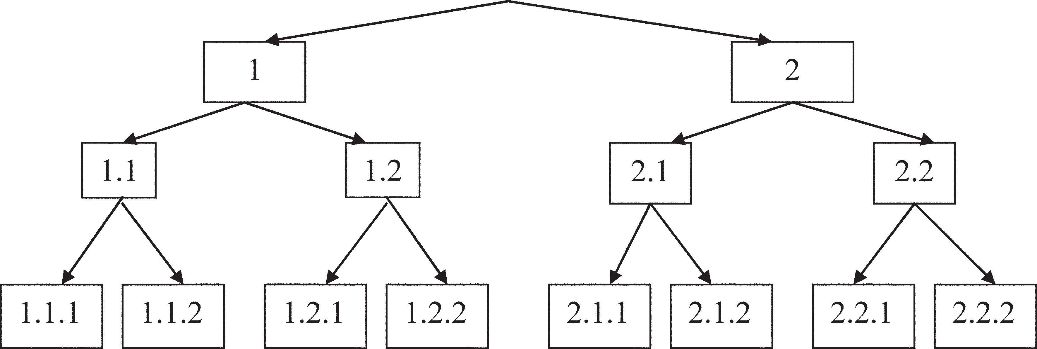

Figure 8.1.Goal tree

.

The construction of the target structure, as a rule, starts from top to bottom, reflecting the logic of deductive progress from the level of a greater degree of community to the level of a lesser degree of community; from the abstract to the concrete; From general to specific. The first Level is the level of the general goal (in Fig. 8.1 it is indicated by the GG), which is the formulation of the final goal setting of what, in fact, was planned to be achieved in the project.

The second level is the level of general goals (in Fig. 8.1, labeled as 1 and 2), which represent the main areas of activity. This is what the designer's actions are aimed at.

The third level is the level of specific goals (in Fig. 8.1 are designated as 1.1, 1.2 and 2.1, 2.2), which represent the main forms of work and provide the main directions of activity.

The fourth level is the level of specific project tasks (in Fig. 8.1, 1.1.1, 1.1.2, 1.2.1, 1.2.2, etc., respectively) are designated, representing those specific project work that, having been completed on time , in a certain way, with the planned result, will ultimately lead to the implementation of the HZ project.

It should be noted that a complex and time-consuming method of structural decomposition is undertaken in order to achieve the fourth level and accurately define all the tasks of the project. Further actions of the designer on the development of the project will be associated only with the fourth level of the target structure.

**8.3.Target structure building rules**

Target structure building rules:

- goals should be formulated very clearly, clearly, unambiguously;

- they must be independent and irreducible to each other;

- the goal of a higher level must be split into at least two goals of a lower level;

- goals of a lower level in the sum should give a goal of a higher level both in terms of content and scope of concepts;

- tasks should be formulated as specific orders of management, unambiguously interpreted and leaving no room for interpretation.

Experts identify the following approaches to building a WBS[5]:

1. Product - building according to the components of the project. The elements of the project's production and its material results are selected as elements of the WBS. Nouns are used to define the names of work packages and individual works (Fig. 8.2).

**ENTEPRIS**E

Business department

trade pavilion

Kitchen modul

Personell

Equipment

wardrobe

Toilets

Bar

Kitchen

Tables

Chairs

premises

vestibule

Figure 8.2. Scheme of the product principle of building a target structure

2. Functional - building WBS by functional elements of activity. As elements of the WBS, the elements of the operations of the technological cycle of the production of products are selected. To determine the name of work packages and individual works, verbs or verbal nouns are used (Fig. 8.3).

**Construction of a residential complex**

Construction work

Equipment

Advertisement

Investigation

Project Management

Geodesic research

Marketing

Marketing

Marketing

Marketing

Marketing

Figure 8.3. Scheme of the product principle of building a target structure

1. Organizational - building WBS according to the elements of the organizational structure. Organizational structure elements are selected as WBS elements. Mostly nouns are used to define work packages and individual work (Figure 8.4).

**House construction**

Construction company

Project Institute

Research Institute

Consulting company

Marketing Department

Geodesic department

External analysis department

Internal analysis department

Organizational investigation department

Figure 8.4. Diagram of the functional principle of constructing the target structure

Topic 9. MOBILIZATION OF PROJECT RESOURCES

9.1. The concept of "resources" and the resource typology

9.2. Analysis availability of enterprise resources

9.1. The concept of "resources" and the resource typology

Position 1. Characteristics types of resources

The concept of "resources" (from the French resource - an auxiliary tool) is very often used in a narrow sense as the financial means necessary for the implementation of a project. It seems more correct to interpret the concept of "resource" in a broader sense - as a set of all means, methods, materials, capabilities and abilities that can be used in the project.

Any resources in the modern world are limited. In fact, the very technology of project management was brought to life due to the severe limitation of all types of resources and the need to save them in every possible way. Therefore, the main task of resource planning is reduced to the optimal use of all their types to achieve the goal with maximum efficiency. Carefully and thoroughly carried out resource planning in the future is the basis for drawing up a reasonable estimate of the project. The resource typology is presented in table 9.1.

Table 9.1

Resource typology

|  |  |
| --- | --- |
| Resource type | Comments |
| Intellectual | the required level of knowledge of the main subjects of project activities |
| Material | availability of premises, equipment, technical means, office supplies, etc. |
| Financial | a set of own and borrowed funds |
| Professional | professional qualification level of the project team |
| Legal | availability of regulatory documents that ensure the implementation of the project (licenses, certificates, regulations, etc.) |
| Organizational | necessary and appropriate organizational units |
| Managerial | availability of team managers who are able to move the project |
| Moral and volitional | innovative readiness of staff |
| Informational | availability of a search system for regular information, a database, etc. |
| Technological | production, personnel, marketing, social technologies necessary for the implementation of the project |
| Others | ____ |

9.2. Analysis availability of enterprise resources

Position 2. Analysis of resources in terms of their availability in the organization (Table 9.2).

Table 9.2

Analysis of resources in terms of their availability in the organization

|  |  |  |  |
| --- | --- | --- | --- |
| Resource type | Current | Potential | Ways of updating |
| Iintellectual  Material  Financial  Professional  Legal  Organizational  Managerial  Moral and volitional Informational  Technological |  |  |  |

Positions 3. Correlation of available and potential resources with the main co-operative subjects (Table 9.3). This position is an analysis of human resources: “with whom do you need to interact within the framework of the project? who is a co-operative and how to ensure his loyalty to the project? "

Table 9.3

|  |  |  |  |  |  |
| --- | --- | --- | --- | --- | --- |
| № | Subjects | Recourses | Strengths | Weaknesses | Interests |
| 1  2  3 |  |  |  |  |  |

Position 4. Development of external and internal communication structures of the project. This position involves the development of external and internal communication schemes for the project.

External communication scheme reflects the processes of interaction with external actors.

Internal - a communication system within the organization. The types of communication networks are shown in Fig. 9.1.

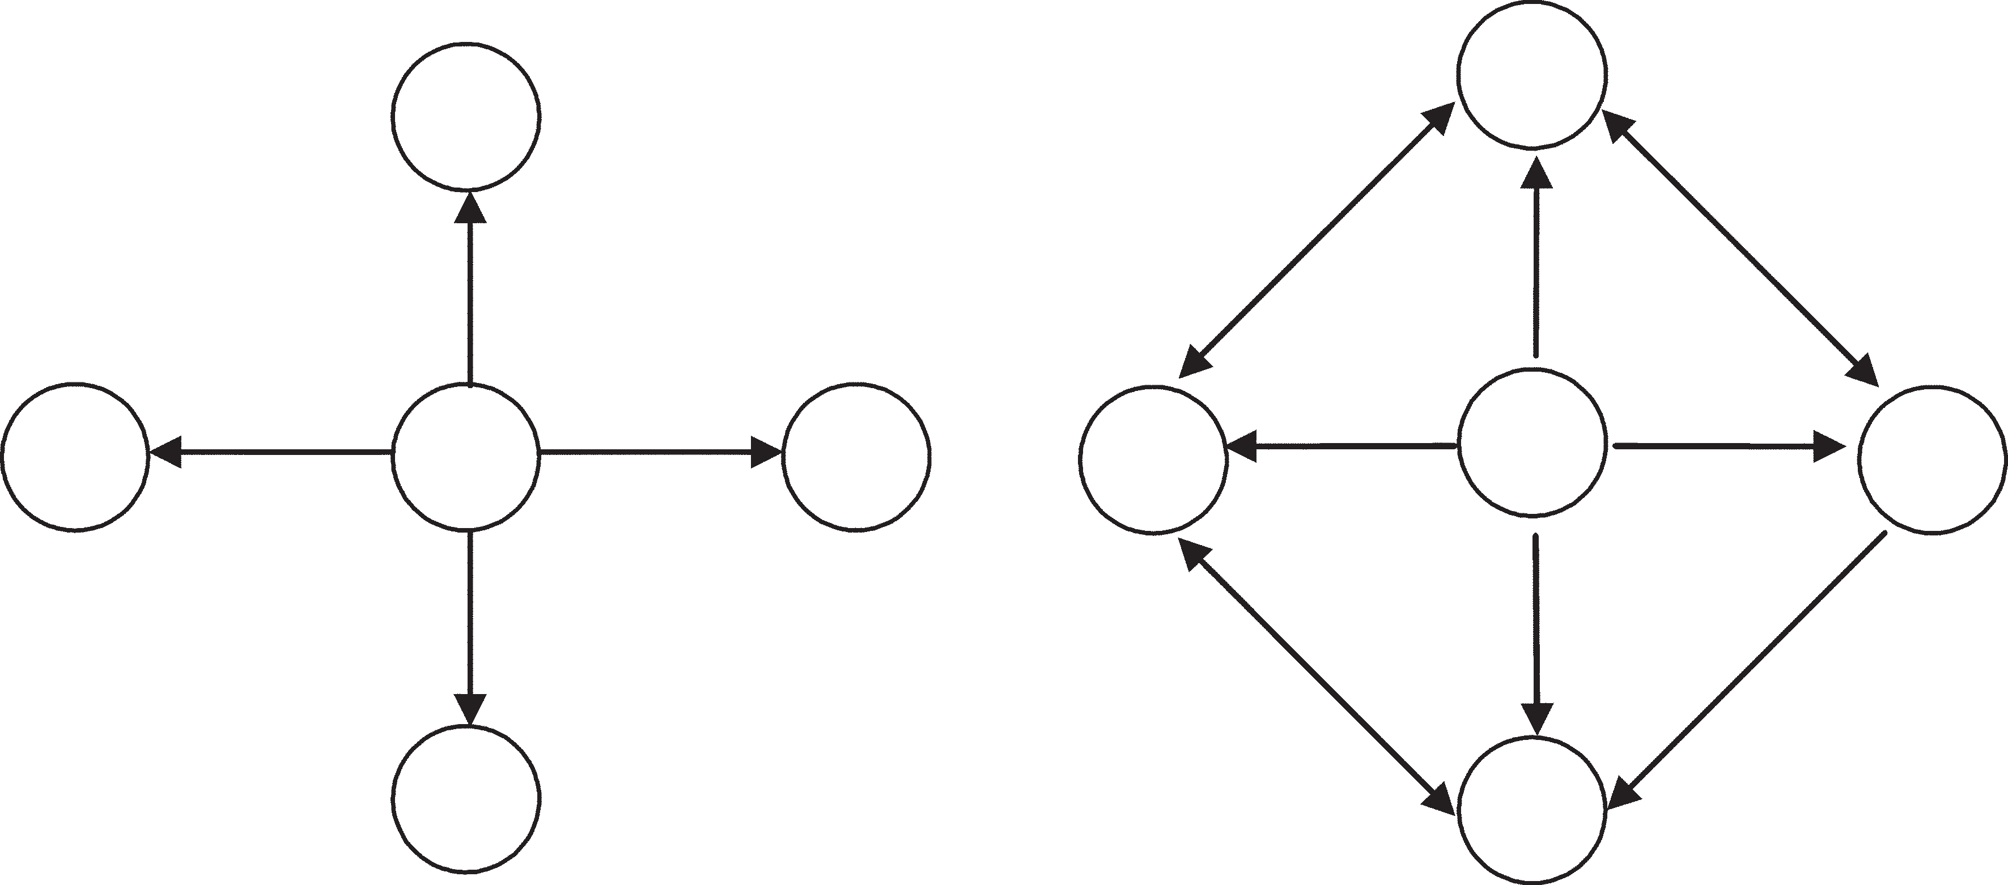

Fig. 9.1. Types of communication networks: a - star; b - spider web

TOPIC 10. DEVELOPMENT AND MANAGEMENT OF THE INSTITUTIONAL SUBSYSTEMS OF THE PROJECT

10.1. Project time management

10.2.Project cost management

10.1. Project time management

Time management is one of the most important subsystems of a project due to the fact that, along with costs and results, it is included in the “magic triangle” of the project and determines the project's time limits. Time management is carried out at all stages of the project life cycle, being implemented in various functions of project management. at the stage of project development, this is planning the time of the project, at the stage of implementation - monitoring the implementation of the network schedule and making changes in the course of the project.

The main task of time management at the planning stage is to develop such a work schedule in which the objective function of the problem, subject to all conditions, would reach an extreme value. in other words, the main task of scheduling integrates the achievement of three conditions:

- minimization of project duration in conditions of limited resources;

- minimization of the project cost;

- even distribution of resources.

the result of the main task of planning time is a reasonable timetable. a calendar plan is design and technological documents that establish a complete list of project works, their sequence, relationship, deadlines, duration, performers and resources required to complete the work. Creating a schedule involves a number of preliminary steps:

1) determination of the duration of work;

2) establishing the relationship between works;

3) determination of the time of availability of all types of resources. the process of determining the duration of work can be carried out

It can be carried out by various methods, in particular by the Delphi expert method, using databases, with the help of internal and external consultants, existing standards, etc. When using the Delphi method, experts independently assess the situation in writing. After that, each expert gets acquainted with the assessments of colleagues and corrects his assessment. The procedure is repeated until the estimates converge within an acceptable time interval.

An analogy method can also be used, in which the results of another project are compared. The method is not applicable in the production of unique innovative works.

the quantitative method takes into account the amount of work and labor productivity. With this method, it is assumed that it is possible to take into account the main factors of the duration of the work: the laboriousness of the bone, the number of performers, the net delay time.

labor intensity of work is the time required for one person to complete this work. Measured in man-hours. it is easy to calculate how the duration of the execution depends on the number of employees. The duration of performance is also influenced by the efficiency of using working time. Certain patterns should be taken into account here. Too optimistic reckoning on the use of all working time for the direct implementation of the project is fraught with unrealistic duration of tasks, which can result in a delay in the project, primarily because the time for completing a task is always lengthened due to the performance of other official duties (meetings, discussions, etc.) , as well as due to unforeseen personal circumstances, when the employee is not available (illness, unplanned breaks, force majeure). According to research by American authors, the real duration of working hours during a standard working day (in hours) is as follows (Table 10.1).

Table 10.1

Duration of real working time depending on the efficiency of use, hours

|  |  |  |  |
| --- | --- | --- | --- |
| Labor intensity | 100% efficient, 100% available | 75% efficient, 100% available | 75% efficient, 75% available |
| 1 person-day | 8 | 6 | 4,5 |
| 1 person-week | 40 | 30 | 22,5 |
| 1 person-month | 173 | 130 | 98 |
| 1 person-year | 2080 | 1560 | 1170 |

The net delay time is associated with a duration that does not depend on the labor intensity of the work, and concerns such situations that require work with documents: approval, obtaining permits, certificates, etc. The labor intensity of the work can be several hours, and the whole procedure will take five days; thus, the duration of the work will be five days.

A clear idea of ​​the duration of the work gives Gantt chart (Chart. 10.1).

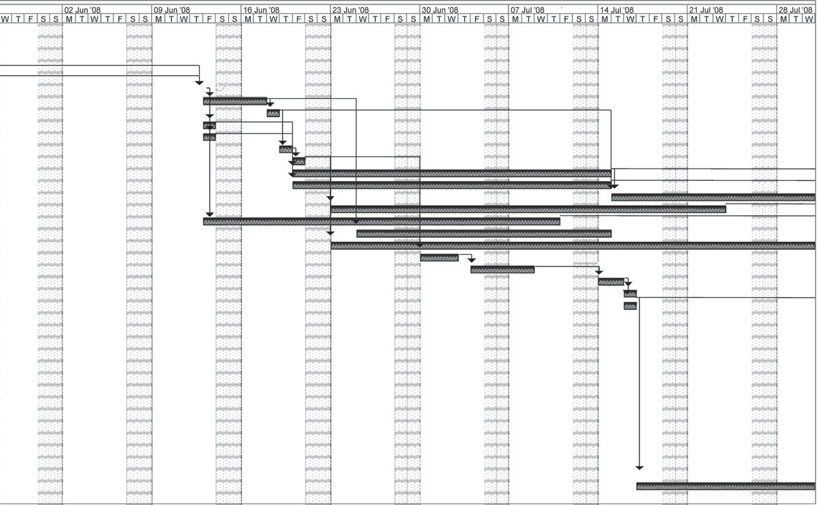

Сhart. 10.1. Gantt chart

The sequence and relationships of the jobs are displayed on the network diagram. There are two types of network charts: traditional and PERT.

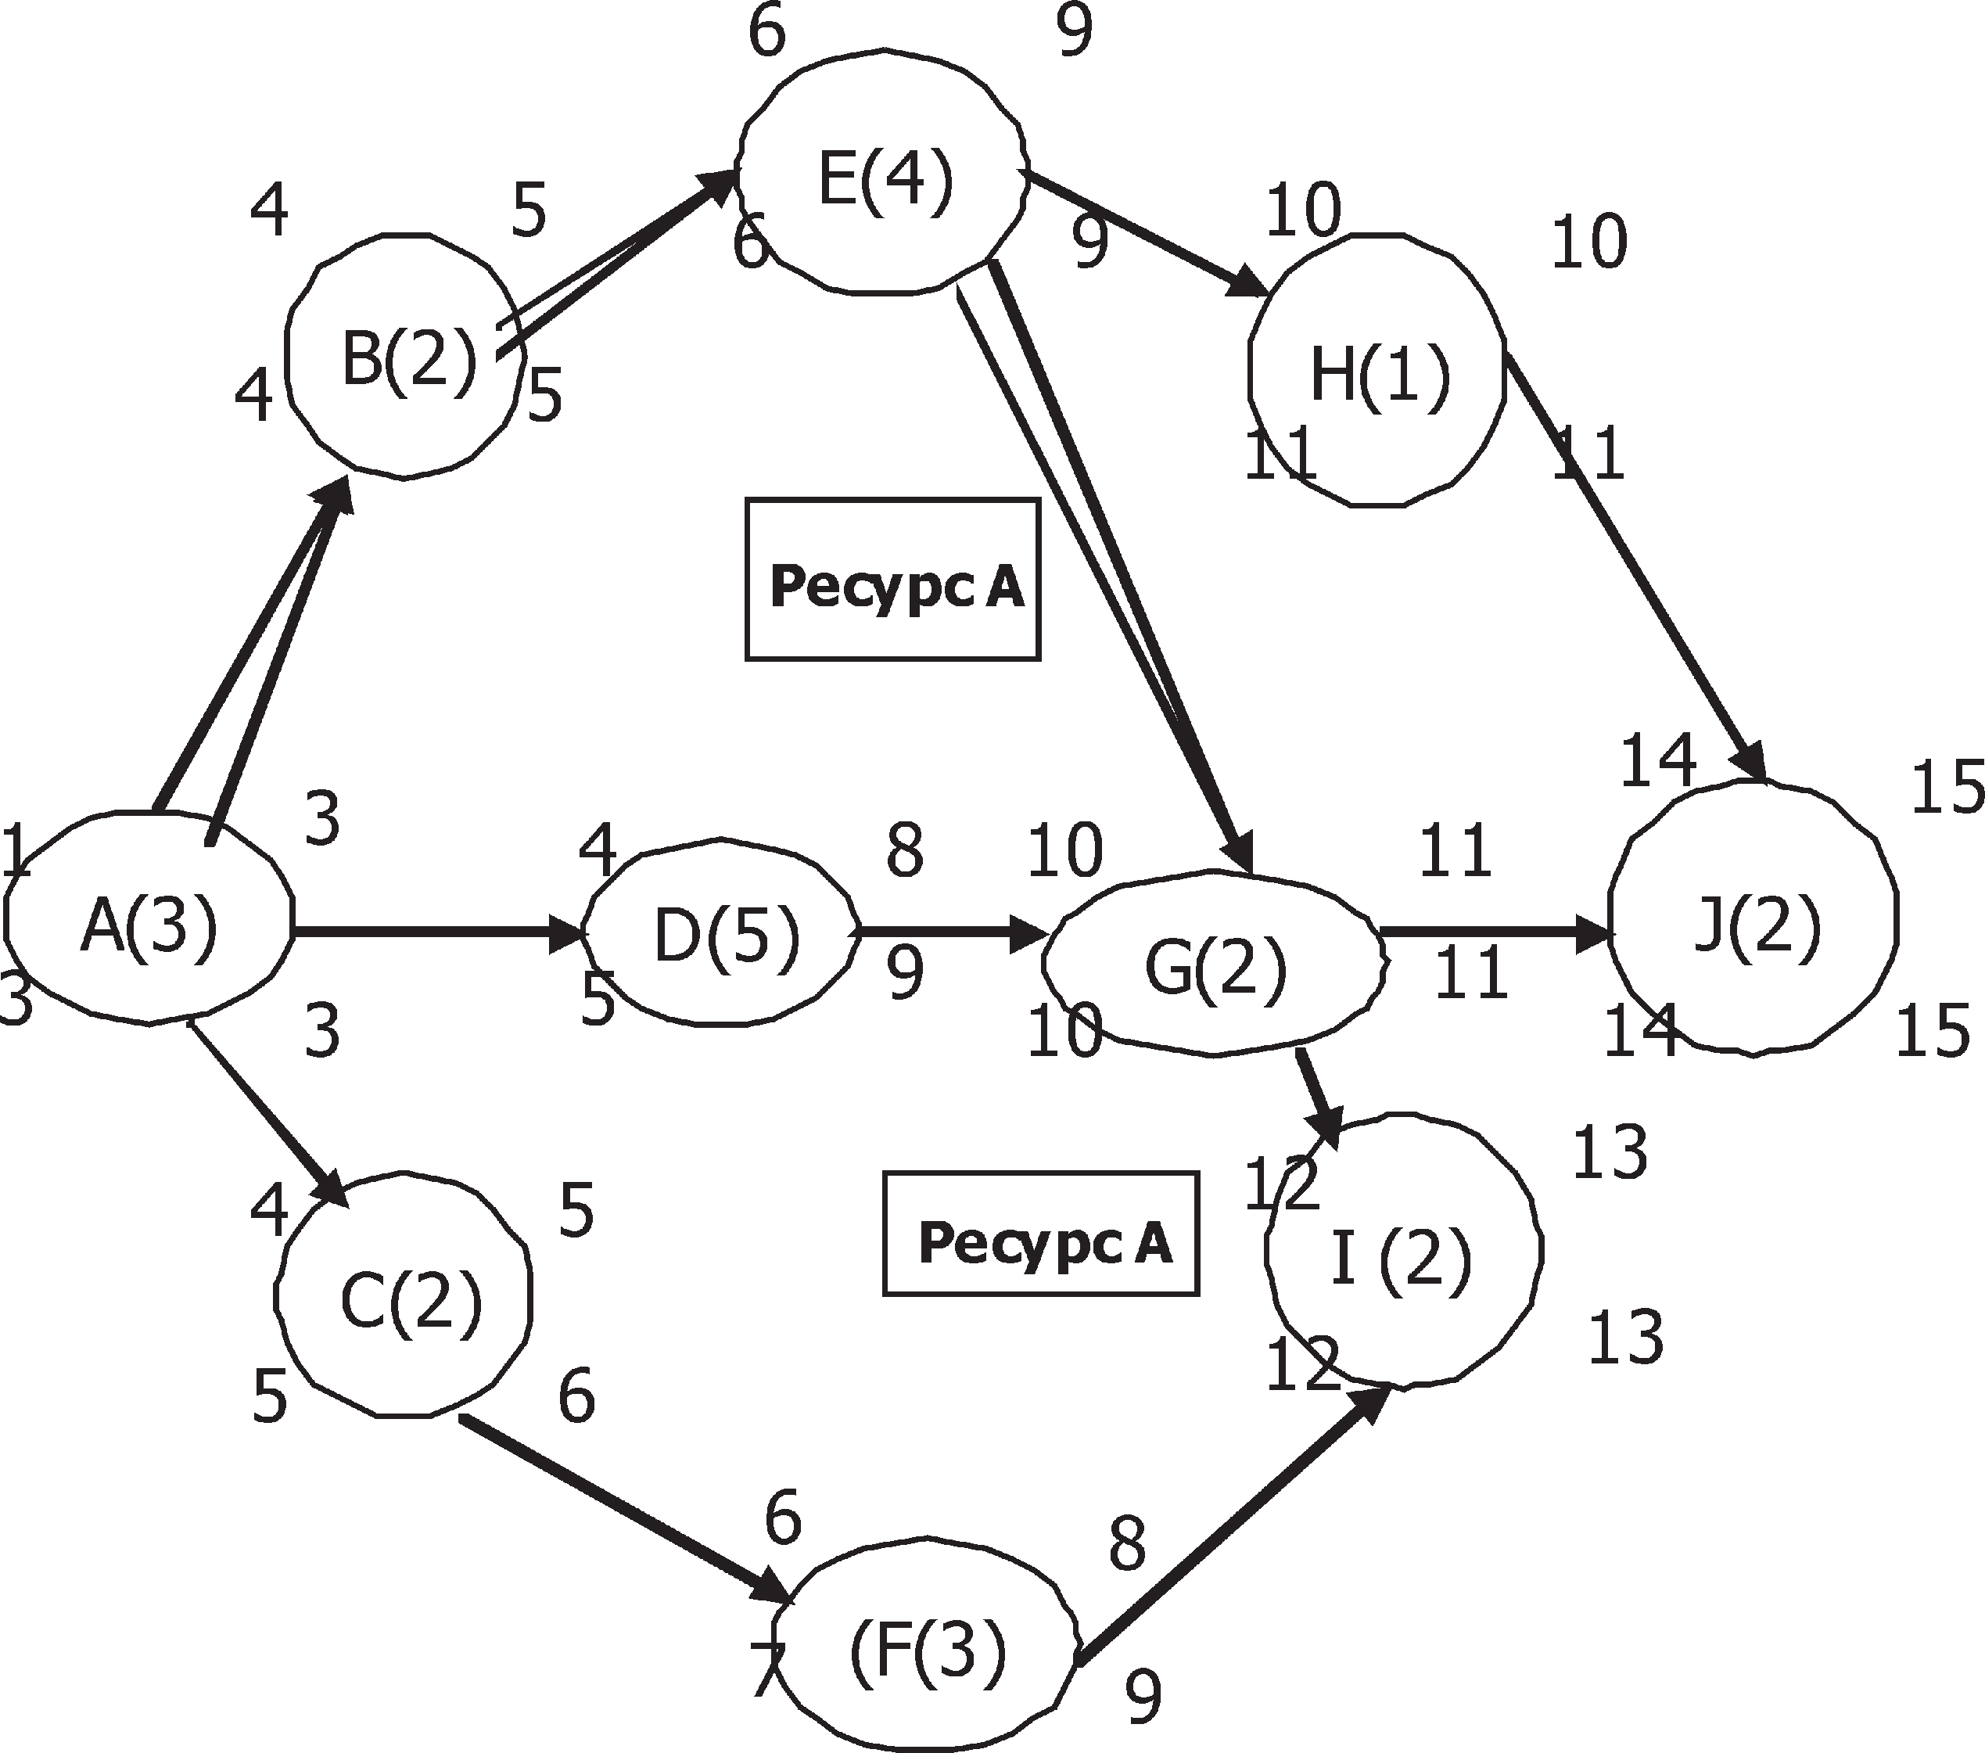 The traditional graph shown in Fig. 10.2, is built according to the principle of the work event, the PERT schedule (Program Evaluation and Review Technique - a method for evaluating and revising the plan) - by the type of communication work (Fig.10.3).

.

Fig. 10.2. Traditional network schedule

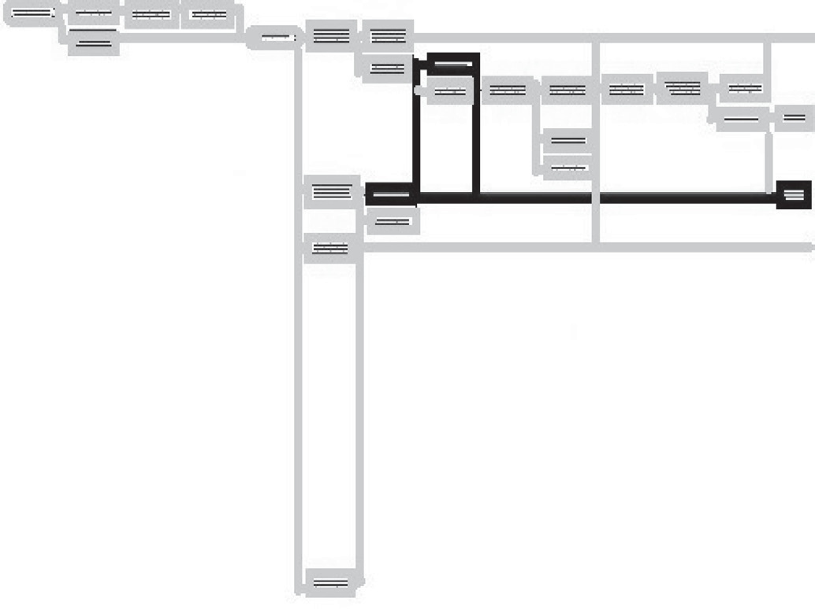

Fig.10.3. PERT Network Schedule

In modern practice, it is the "work-communication" network schedule that is more often used, because it is much more convenient, since it can display both work and events, and, in addition, the Microsoft Project computer program, the most popular in everyday life, also works according to this principle. Practice of project management.

Basic rules of the network schedule:

1) After the completion of the previous work, you can proceed to the execution of the next one, to which the arrows go (see Fig. 10.3);

2) You can start work only after completing all the previous work, from which the arrows lead to the desired work (see Fig. 10.4).

To understand the meaning of network planning, it is also necessary to define the key concepts of network planning.

The critical project path is the sequence of work in the project that takes the longest time to complete, that is, it is the longest chain of work. All the work that lies along this path are called “critical tasks,” and an unplanned lengthening of any of them will lengthen the entire project. it is obvious that it is the length of the critical path that will determine the deadline for the entire project. The concept of a critical path allows planning both from the start date of the project and from a fixed end date, which is very convenient for the project manager; then in the first case it is necessary to determine the end date, and in the second - the start of work. The critical path is determined by calculating the Early Start, Late Start and Early Finish, Late Finish for each job.

Non-critical project path - a sequence of work that can be completed with some delay without increasing the duration of the project. This is due to the fact that the non-critical path is by definition shorter than the critical one and therefore contains a certain reserve of time, due to which any task lying on the non-critical path has a certain time gap and can move along the time axis. thus, the slack is the maximum time by which it is possible to shift a task lying on a non-critical path without increasing the project timeline.

Due to the possibility of movement of non-critical tasks along the time axis, it becomes possible to determine the exact dates of the earliest start - the end and the latest start - the end of the work.

A direct network analysis is undertaken to determine the length of the critical path and to set the early start-end dates of the project. to establish late start - end dates and, accordingly, the amount of time reserves - reverse analysis.

Of course, in practice, more complex dependencies and connections are also used. a specific schedule depends on many reasons: on the complexity of the sequences and relationships, on the tasks facing the project manager, on the type of project software, etc. (Fig. 10.4, 10.5, 10.6).

**Start-Start**

Operation B starts not-before operation A

**Finish-Start**

Operation B can not starts before completing operation A

A

A

B

B

Fig. 10.4.Types of work relationships

The final document of time planning, as already indicated, is the schedule. The standard timetable should include specific deadlines, time reserves, and the names of the team members in charge.

B

B

A

A

**Start-Start**

Operation B cannot finished before starting operation A

**Finish-Start**

Operation B will not finished before completing operation A

**Fig. 10.5. Interrelation of works like "Finish - Finish" and "Start - Finish"**

**Start** - **Finish**

Operation B should be started in the moment of completing operation A and continued up to starting operation C

C

A

B

**Fig. 10.6. Interrelation of works "hammock"**

Modern software allows you to combine all this information on the Gantt chart, indicating the required types of resources.

Table 10.2

Milestone plan

|  |  |  |  |  |  |  |
| --- | --- | --- | --- | --- | --- | --- |
| event | March | April | May | June | July | August |
| the contract has been concluded  the specification has been completed  the design has been developed  the system is tested  the system is connected |  |  |  |  |  |  |

Signs: — Plan date; — Actual date.

Depending on the situation, the form of presentation of the schedule may be different. For example, it can be a schedule of key events "plan for milestones", presented in table. 10.2.

The calendar plan can be presented in the traditional form as a familiar table with the indication of the dates of events and those responsible for implementation (Table 10.3).

Table 10.3

**Calendar plan**

|  |  |  |  |  |  |
| --- | --- | --- | --- | --- | --- |
| No. | Name of tasks | Start | End | Reserves | Responsible |
| 1 | Preparation of  documents | 03.03.08 | 10.03.08 | Critical  task | Qurbanova F.H. |

It is possible to present a calendar plan in the form suggested in the Microsoft project program, It is very convenient for day-to-day management activities.

When developing a project schedule, a resource conflict situation may arise. resource conflicts are the discrepancy between the resource consumption limit (opportunity) and the need for a given resource to do the job. Conflict Resolution Methods:

- compression;

- stretching;

- normalization;

Compressing the scheduling of work leads to a reduction in the time of the project, but increases the risks.

Compression methods:

- Crashing - attracting additional resources to speed up the execution of work on the critical path (purchase of additional resources; work outside of school hours; reallocation of resources from tasks that are not on the critical path);

- Fast Tracking - parallel execution of phases or work of the project, which in normal practice are performed sequentially.

It is the parallel execution of the project's work that makes it possible to shorten the critical path and, accordingly, the project timeline. This compression method introduces non-critical project paths.

**10.2. PROJECT COST MANAGEMENT**

Cost management is carried out at all stages of the project life cycle and includes the following processes to ensure that the project is carried out within the approved budget:

- cost estimate;

- development of estimates and budget of the project;

- cost control (Cost Control).

Thus, the main goal of cost management is to develop policies, procedures and methods that allow you to plan costs and control them in a timely manner using a variety of methods.

Cost management processes are implemented differently at different stages of the life cycle, and the cost of a project itself is distributed unevenly throughout the life cycle. The main part of the cost is spent on the implementation, implementation of the project, but it must be remembered that the main decisions that determine the indicators of the cost of the project are made at the pre-investment phase. This is the source of not only the critical importance of that phase, but also taking into account the possibility of cost management - it decreases in proportion to the progress towards the end. An approximate distribution of funds by phases of the life cycle is shown in Fig. 10.7.

|  |  |  |  |  |
| --- | --- | --- | --- | --- |
| |  | | --- | | Cost,% | | |  |  |  |
| Pre-investment phase | Investment phase | Phase of operational tests |
|
|
|
|  |  |  |
| 12 | 60 | 28 |
|  |  |  |
|  |  |  |
|  | Time | | |

**Figure10.7. Allocation of funds by phases of the life cycle**

Cost Estimating - determination of the cost of resources required to perform operations (tasks of the target structure) of the project:

- equipment (purchase or rent);

- fixtures (devices and production facilities);

- working labor (staff and contract workers);

- consumables (stationery, etc.);

- raw materials and supplies;

- training, seminars, conferences;

- subcontracts;

- transportation costs.

There are various methods and types of project cost estimation. in table. 10.4, the types and purposes of the assessment are presented, depending on the stages of the project.

Table 10.4

**Project cost estimation methods**

|  |  |  |
| --- | --- | --- |
| **Project implementation stage** | **Types of assessments** | **Purpose of evaluations** |
| Project concept  Investment justification  Development of working documentation project implementation  Commissioning completion  the project | Preliminary assessment of project viability  rough cost estimate - preliminary estimate, final estimate documentation  1. Actual (based on already completed work).  2.Predictable (for upcoming work)  1. Actual.   1. 2.Predicted Actual | Project feasibility assessment  Comparison of planned costs with the organization's budget  basis for calculations and project cost management  1.Evaluation of the cost of work already performed.  2. Estimation of the cost of the work to be carried out  -  Full project cost estimate |

Methods and tools for assessing the cost of resources:

- evaluation by analogs - by analogy with previous similar projects or works;

- determination of the rates of the cost of resources - assessment according to the parameters of the project (cost of 1 hour of work + cost of a unit of material);

- Bottom-Up Estimation — Estimating the cost of individual jobs, then work packages, and so on (from the lower to the upper levels of the WBS). thus, to estimate the cost of the project, it is necessary

the following information:

- the cost of the resources that make up the project;

- time of work execution;

- the cost of these works.

the cost of the project is determined by the totality of the costs of the project resources. the main document through which

the project cost is managed, is the project budget.

The budget is a directive document, which is a register of planned expenses and incomes with distribution by item for the corresponding period of time. budget - a document that defines the resource constraints of the project.

The budget can be formed within the framework of traditional accounting. depending on the stage of the project life cycle, budgets can be:

- preliminary (estimated);

- approved (official);

- current (adjustable);

- actual.

the essence of budgeting is planning the cost of a project, that is, a certain cost plan: when, how much and for what money will be paid and received. The cost component of the budget is called the estimate. the ways of presenting the cost estimate can be completely different and depend on the goals of the documentation, the prevailing traditions and the wishes of the customer. the estimate can be presented in the form of calendar schedules (Table 10.5), bar charts, bar charts of cumulative costs (Fig. 10.8), linear charts of cumulative costs distributed over time, pie charts reflecting the structure of project costs (Fig. 10.9).

Table 10.5

**Schedule plan-timetable of costs, TJS**

|  |  |  |  |  |  |  |
| --- | --- | --- | --- | --- | --- | --- |
| № п/п | Works | Jan | Feb | Mar | Apr | May |
| 1 | Take cases | 15 |  |  |  |  |
| 2 | Punch (enter data) |  | 300 |  |  |  |
| 3 | Check base |  |  | 550 |  |  |
| 4 | Form a package |  |  |  | 280 |  |
| 5 | Arrange an archive |  |  |  |  | 10 |

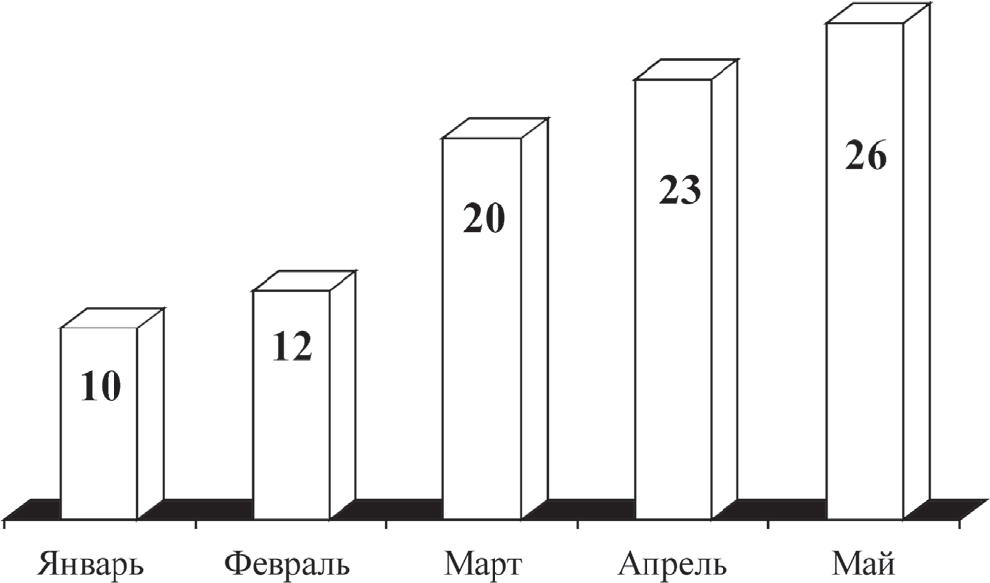

**Figure 10.8. Bar chart of cumulative costs, rubles**



After acceptance, agreement and approval, the budget and estimate become the benchmark against which the actual result is compared, and the main document of the project.

Controlling project costs is part of overall change management and involves looking for causes that cause both positive and negative deviations. For example, inadequate response to cost deviations can lead to scheduling or quality issues, and unacceptable increases in risk later in the project[6]. Cost control includes the following procedures:

- establishing the actual cost of the project;

- comparison of the actual cost with the planned one;

- forecast of the future total cost of the project.

There are two main cost control methods: traditional and earned value.

The traditional method works well (and is therefore widely used) to determine the state of affairs at the end of the project to determine the discrepancy between the actual and planned costs of the project. When applying the traditional method, the following indicators are introduced:

Planned Value (PV) - planned volume, planned cost of planned works.

Planned budget costs: BCWS (Budgeted cost of work scheduled).

ACWP (Actual cost of work performed) - the actual cost of work performed, the amount of funds actually spent on the performance of work before a fixed date, independent of budget targets.

Comparing the last two values ​​gives us a cost discrepancy, a cost discrepancy (COST VARIANCE) and allows us to determine cost overruns or cost savings:

CV = ACWP - BCWS.

The second method is convenient specifically for the project, since it takes into account the availability of the work schedule and allows you to establish not only the deviation in costs, but also the deviation from the work schedule. One of the widespread technologies of value analysis is Earned Value Analysis. Analysis of the achieved volume - an integrated analysis of both the execution of the project schedule and the budget in terms of cost indicators. for this to two indicators defined in the traditional method

The third is added - the budget cost of actually performed work Earned Value (EV) or in CWP (budgeted cost of work performed) - the earned value, the planned cost of the work performed. the earned value does not depend on the actually performed work costs incurred.

The cost variance is a value derived from the difference between the actual cost of work performed (ACWp) and the planned cost of actually performed work (in CWP). This dependence is reflected in the following formula:

CV = ACWр – BCWS

The deviation from the schedule is determined by the difference between the planned cost of the work on the BCWS schedule and the planned cost of the actual work performed by the BCWP.

T = BCWS – BCWр

One of the tasks of cost control is to establish a forecast estimate of the project cost based on information about the project costs at the current time. The final cost of the project can be estimated using the traditional and earned value methods.

CPI (Cost Performance Index) - budget execution index, it is determined by the formulas:

CP = EV - AC, CPI = BCWP – ACWP

CPIс (Cumulative CPI) is a cumulative budget execution index, it is determined by the formula:

CPIс = EVс ÷ Acc

SPI (Schedule Performance Index) - the index of the execution of the schedule, determined by the formulas:

SPI = EV ÷ PV, SPI = BCWP ÷ BCWS

Thus, it is possible to make a forecast about the cost of both the entire project as a whole and its remaining part at the time of completion of the project (Table 10.6).

Table 10.6

**Predictive valuation methods**

|  |  |  |
| --- | --- | --- |
| ETC | EAC | Notes |
| New estimates of the remaining work | Acc + new estimates of the remaining work | Method based on new estimates is the most accurate method |
| BAC – EVс | Acc + BAC – EVс | Method based on atypical changes (if the costs incurred differ from the forthcoming ones) |
| (BAC – EVс) / CPIс | Acc + ((BAC –  EVс) / CPCс) | Method based on typical deviations (if the costs incurred are similar to the forthcoming ones) |

In practice, the following abbreviations are used:

- BAC (Budget Completion) - the planned cost of the entire project;

- ETC (Estimate to Completion) - an estimate of the cost of the rest of the project;

- EAC (Estimate at Completion) - project cost estimate at completion.

Let us illustrate the theoretical material by solving a specific problem. Example: In a house construction project, the planned productivity is 1 floor in 3 weeks with the planned cost of the 1st floor $ 123,250.

find the deviation in terms of time (SV) and cost (CV), if by the end of the 3rd month (in the month of 4 weeks) 5 floors were completed, and the cost of the work performed was $ 630,750.

Solution

PV = 3 • 4/3 • 123,250 = $ 493,000

TV = 5 • 123 250 = 616 250 USD

AC = 630 750 USD

CV = EV - AC = –14,500 dollars - cost overruns; SV = EV - PV = $ 123,250 - lead time.

**Topic 11. PROJECT QUALITY MANAGEMENT**

11.1.The quality management application and definition

11.2. The quality management processes

**11.1. The quality management application and definition**

Project Quality Management is one of the main functions of a project team. Project quality management includes those processes that are necessary to ensure that the project meets the requirements for which it was undertaken. Quality is understood as an integral set of characteristics of an object related to its ability to meet established or anticipated needs[7]. Quality management applies equally to:

- to project management;

- the product of the project.

Thus, the project can be divided into two aspects that must be considered in an inextricable relationship and interdependence. Quality management is the key to a quality product. Only a quality project can create a quality product. Good project management can be understood as project planning, project execution, project resource planning, control of all aspects of project work. The evolution of Quality Management is illustrated in Fig. 11.1.

|  |  |
| --- | --- |
| Taguchi | Strategic quality management: quality is a competition advatage and profit in the market |
| Grosby | Quality Planing - problems forecast, but not their identification: zero-defect-programs |
| Deming | Quality control: statisticl methods, diagrams of procedures |
| Juran | Inspectation: defects sampling |

Fig. 11.1. The evolution of quality management

PMI PMBOK's core approach to project management is in line with ISO 9000 and ISO 10000 quality standards and modern quality concepts. here is the definition of ISO quality:

"A set of characteristics of an object that allows it to meet the stated or implied requirements"[8].

A critical aspect of quality in the context of project management is the need to reflect implied requirements in the project scope.

Satisfy the requirements of all customer groups and stakeholders (where possible).

**11.2.The quality management processes**

Quality is the result of quality processes, not constant control.

basic principles of PMI quality management:

- customer satisfaction - ensuring both the formal requirements of the customer (reflected in the contract) and the informal expectations of end users from their use of the product (project result);

- prevention before elimination, - prevention of the appearance, but not elimination of already existing defects (loss of product quality);

- management responsibility - management (of the project and the company) is responsible for the allocation of resources required to manage product quality;

- continuous improvement - the entire project team is continuously working to improve the project execution processes and increase the quality of the product4[9].

Quality management processes:

- quality planning - determination of quality standards applicable to the project, and measures to achieve them (Fig. 11.2, 11.3). Proper planning requires information on a wide variety of aspects of quality in a project - from the quality strategy to the most detailed documents governing the entire quality system in the project, regarding the project scope, specific specifications, service standards, information on technological processes, etc. ;

- quality assurance - carrying out all planned systematic actions within the quality system (for example, an audit) to ensure that the project engages all processes necessary to meet all stakeholder expectations. Quality assurance is achieved by regular inspections based on a pre-approved quality plan, technological maps, checklists, as well as the results of verification tests (Fig. 11.3.).

.

|  |  |  |
| --- | --- | --- |
| -External environmental factors;  -organizational process assets;  -description project content;  - project management plan | -Profit and cost analysis;  - Benchmarking;  -planning of tests;  - cost of quality;  - additional instruments quality planning | -plan quality management;  Quality assessment results;  -control list procedures of quality control;  -quality baseline;  -project management plan |

**Fig 11.2. quality planning**

**Quality cost**

cost of compliance

Cost of discrepancy

External troubleshooting:

-returns to suppliers;

-compensation to suppliers;

- guaranty repair

Prevention:

- Analysis and study of processes;

- training;

- supplier analysis;

- quality planning

Internal troubleshooting:

- alteration;

-corrective action;

- repair;

- simple repair

Testing:

- tests;

-checks and inspections

**Fig. 11.3. Quality cost planning**

- quality control - tracking project results to determine their compliance with accepted quality standards and identifying ways to eliminate the causes of unsatisfactory performance. the sequence and control methods are shown in Fig. 11.4 respectively.

Requested changes;

Recommended corrective actions;

Organizational process assets;

Updated project management plan

Quality planning tools and methods;

Quality analysis;

Quality audit;

Process analysis;

Quality control tools and methods;

Quality management planning;

Quality assessment results;

Process improvement plan;

Information about the execution of work;

Approved change requests;

Quality control results;

Change requests processed;

Corrections made;

Corrected defects;

Preventive action taken

**Fig. 11.4. Quality assurance**

To ensure the effective operation of the quality management system, regular checks are carried out for deviations of the system from the specified standards. The verification method is system audit, process audit and project product audit.

An audit is a systemic independent study conducted in order to establish the compliance of quality activities with the adopted plan, how effective these activities are and whether they will lead to planned goals.

The quality management system can be certified, as well as products that are carried out according to ISO standards by the relevant body.

Quality management at any level ends with the formulation of some conclusions. conclusions can be presented as an algorithm of actions of a quality manager and as a reporting structure in the field of quality management:

- quality improvement; improvement activities;

- acceptance of products in accordance with specifications and standards;

- identification of defects and implementation of actions for the management of unsuitable products;

- product processing;

- making changes to technological processes that lead to marriage;

- summary assessment of the quality of project results;

- decision on final acceptance;

- drawing up a list of comments and quality claims;

- resolution of controversial issues and conflicts;

- registration of documents in the archive;

- experience analysis and lessons learned in quality management.

**Topic 12. PROJECT TEAM MANAGEMENT**

12.1. Project team

12.2. Formation of a project team;

12.3. Development of the project team;

12.4. Project team management or Conflicts, their role and methods of resolution.

**12.1. Project team**

In the scientific literature today there is no unity in the interpretation of the concepts of “project team”, “project management team”, “project participants”. so, in particular, in the English-language literature the following interpretation of these concepts prevails.

A project team is a collection of individuals, groups and / or organizations involved in the implementation of project work and subordinate to the project manager.

Project management team - members of the project team who are directly involved in project management work. In small projects, this team may include virtually all members of the project team.

Project participants - persons interested in the project. The previously mentioned textbook edited by I.I. Mazur contains slightly different accents: it is customary to combine specialists and organizations into completely specific groups of project participants, which include customers, investors, etc. It should be noted that project participants are a broader category than the project team[10]. “The project team is a group of employees directly working on the implementation of the project and subordinate to the project manager; the main element of its structure, since it is the project team that ensures the implementation the idea of ​​the project. This group is created for the period of the project and is disbanded after its completion[11]”. In fact, the authors of the cited tutorial identify the project team with the participants, and the project management team with the project team.

Team management includes the following processes:

- formation of a project team;

- development of the project team;

- project team management.

Let's consider these processes in detail.

**12.2. Formation of a project team**

The main characteristics of the team are:

- composition;

- structure.

Composition is a set of characteristics of team members that are important for its analysis as a whole (for example, numerical, age, gender, professional composition). The formation of the project team is carried out in the process of personnel planning, which is based on knowledge of the answers to the following questions:

- how many specialists, what qualifications, when and where will be required;

- how you can attract the right staff;

- how best to use personnel in accordance with their abilities, skills, internal motivation;

- how to provide conditions for personnel development. The answer to the first question is obvious: it is determined by the scope of work envisaged in the project. The managers of the functionally or subject-oriented groups make up a team.

The second question is related to the system of incentives and motivations of the team. Common theories of motivation:

- the theory of justice - people constantly compare their own labor costs with the results obtained;

- expectation theory - more effort is applied when employees expect to be able to complete their task and receive a reward;

- the theory of reward - it should be continuous, but not fixed;

- goal setting theory - the goal should be clearly defined, interesting and achievable;

- performance model - people should use a variety of skills, receive tasks with visible results and have a certain autonomy.

Structure is a characteristic of the team in terms of the functions performed by the team members. the structure of the team is determined during the organizational modeling of the project.

Organizational structure - a set of elements of the organization (job positions, structural units) and the relationship between them.

Administrative ties are vertical ties within which the problems of power and influence are solved, and administrative decision-making processes take place.

Technological links are horizontal links through which the processes of work are carried out.

The general principles of building organizational structures for project management include the following:

- compliance of the organizational structure with the content of the project;

- compliance of the organizational structure with the system of relationships between project participants.

Approach 1. The project is implemented within a separate organization.

Organizational design alternatives:

- functional organizational structure;

- project organizational structure;

- mixed organizational structure.

In the functional structure, projects are usually carried out within the functional unit. if it is necessary to attract specialists from other departments, coordination is carried out at the level of managers. This type of organizational structure is shown in Fig. 12.1.

Work on the project is carried out as an additional task in the framework of daily activities. Senior management identifies a project manager (functional leader) who, within the organizational structure, performs his or her normal responsibilities, but manages the project team with professional access to relevant people. The advantages and disadvantages of this type of organizational structure are quite obvious. In any disputable case, the priority on the part of the employee will not be given to the project manager, but to his functional leader, which can have a detrimental effect on the timing and results of the project. This type of organizational structure allows you to significantly save money, since in the estimated planning in this case there is no item "salary", limited to some remuneration within the accepted size. 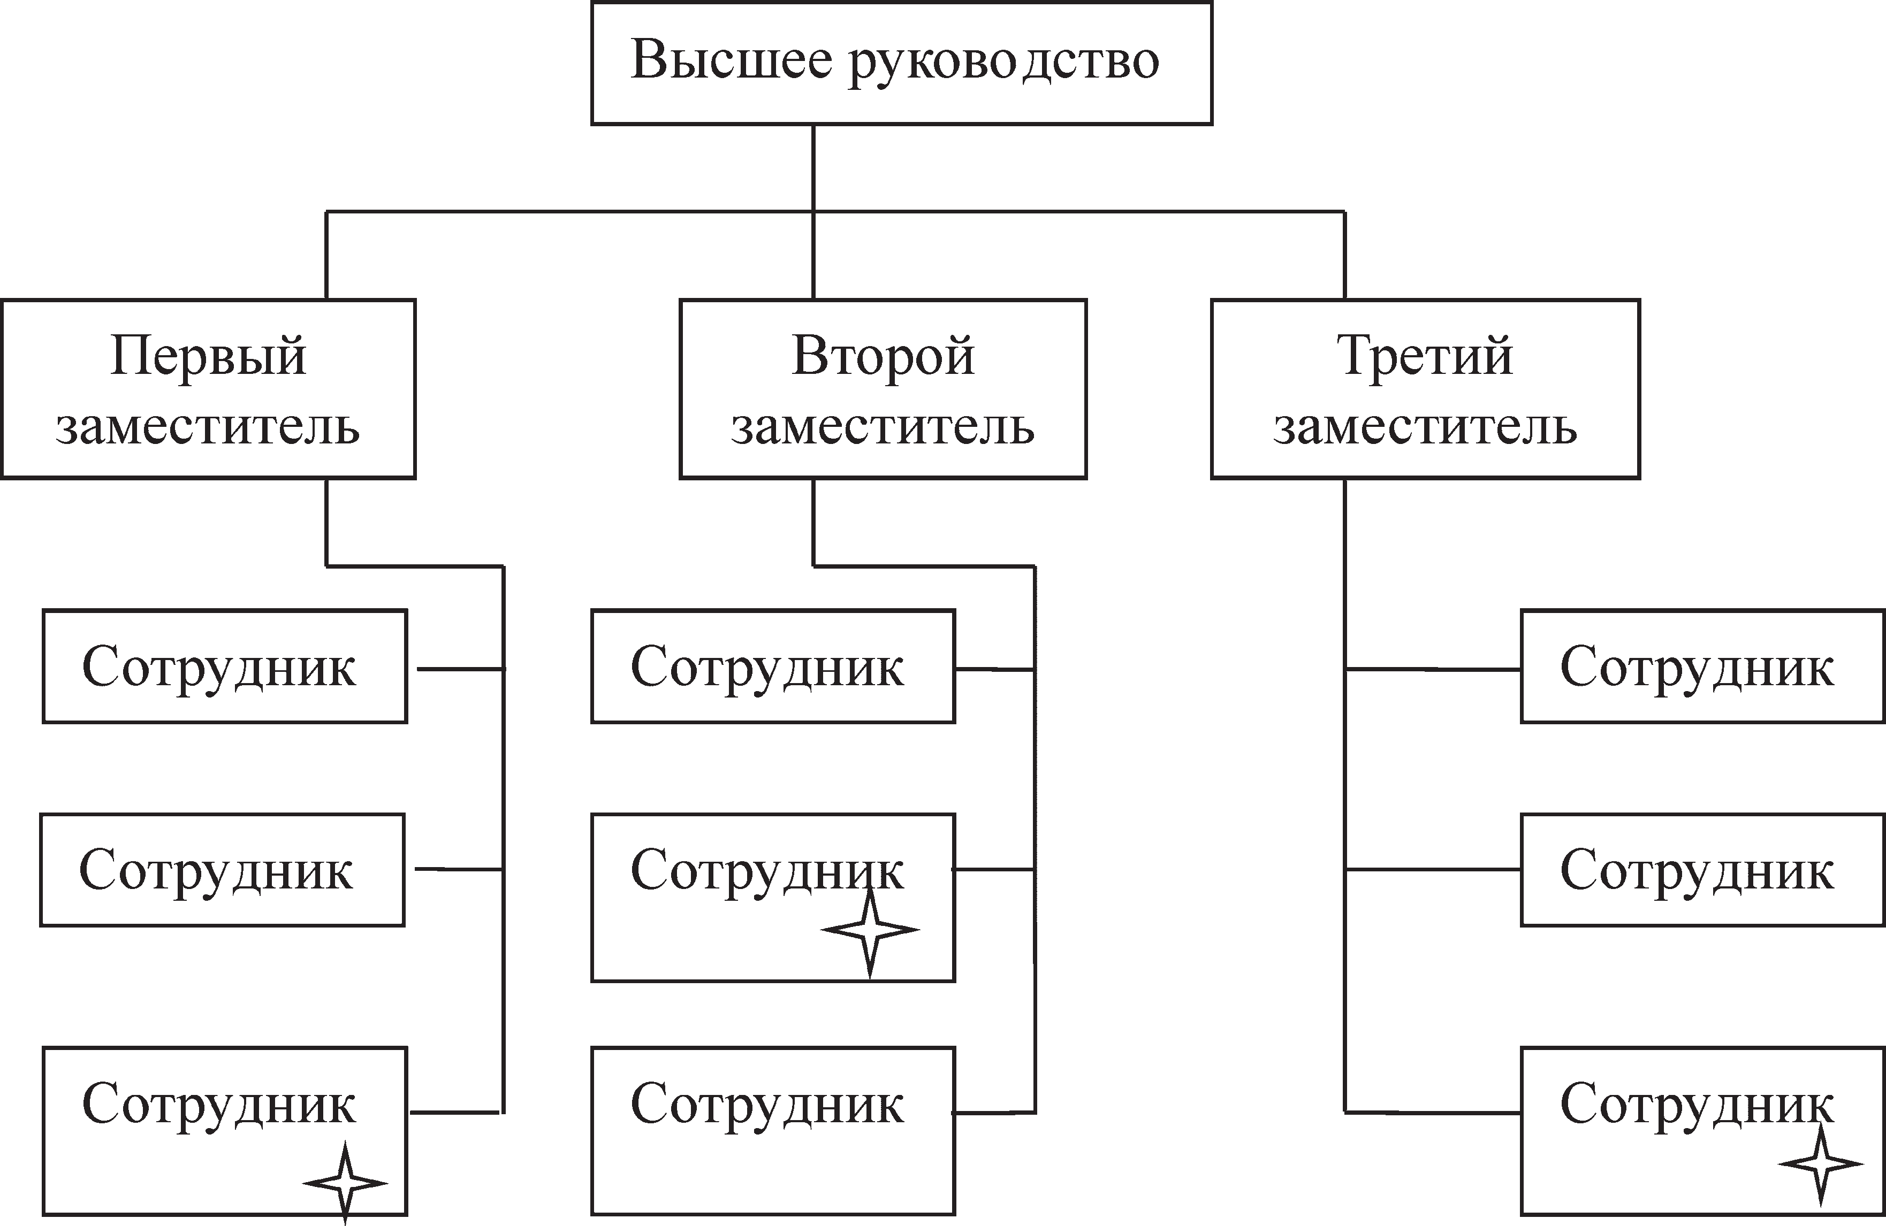

**Fig 12.1. Functional organizational chart of a team**

The mixed organizational structure of the project is built on a functional basis. only the project manager is relieved of his duties.

Approach 2. The project is being implemented outside the framework of one organization, that is, the team is formed mainly from representatives of various organizations. in such cases, for a specific project, specific structural formations are created on a matrix basis.

The management model reflects the connections and relationships between team members (Figure 11.2.).

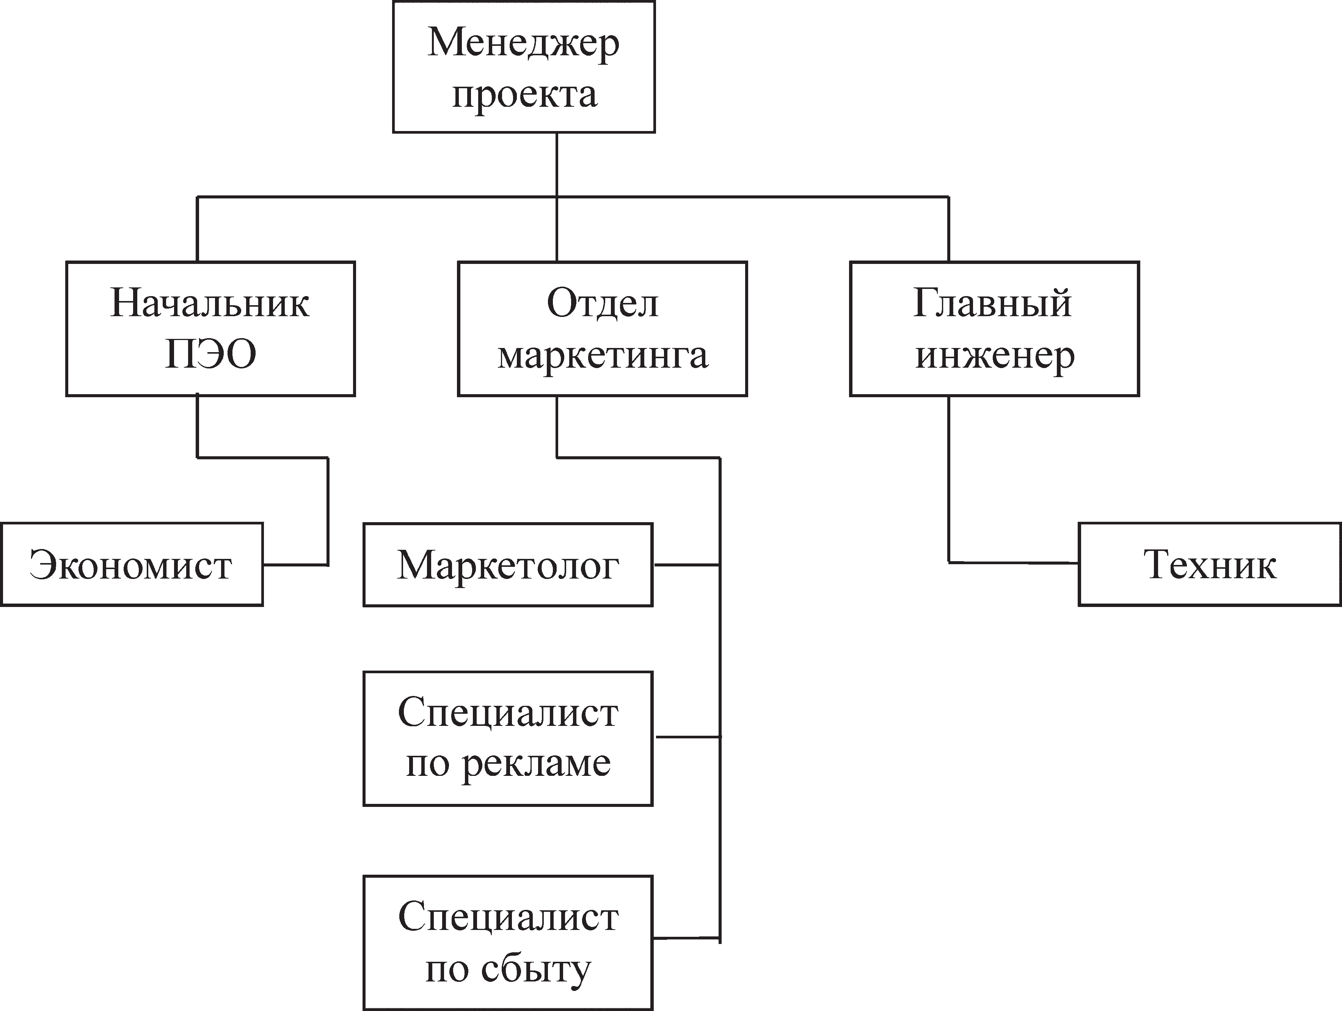

**Figure 12.2. Project management model diagram**

In a project, it is extremely important to choose the right type of team organizational structure. the organizational structure of the team must meet the specifics of the project. principles and criteria for choosing the organizational structure of the team are reflected in table 11.1.

final planning documents of the project personnel:

- the staffing schedule of the project (list of the names of the performers, position, payment);

- Responsibility matrix - a document reflecting the distribution of roles and responsibilities;

- personnel management plan.

Table 12.1.

**Principles of choosing the organizational structure of the project**

|  |  |  |
| --- | --- | --- |
| Parameter | Organizational structure | |
| Functional | Design (matrix) |
| Uncertainty of the conditions for the implementation of the project | low | high |
| Technologies in the project | standard | new |
| Complexity of the project | low | high |
| Project scope (duration, budget) | Small | large |
| Project priority | normal | high |
| Time criticality | low | high |

For a visual representation of the distribution of responsibilities, a responsibility matrix is ​​drawn up as a very convenient working tool (Table 12.2.).

Table 12.2.

**Responsibility matrix**

|  |  |  |  |
| --- | --- | --- | --- |
| **Project objectives** | **Executive Secretary** | **Deputy Executive Secretary** | **Dean** |
| Project objectives  Check base with cases in folders  Enrollment of budget students for the 1st time  Enrollment for the 2nd time  Moving the cases of enrolled students to a separate box  To put stamps in the selection committee on extracts and wherever it is necessary to get work from the selection committee | +  + | +  + | +  + |
| put unclaimed cases in a box alphabetically, originals - separately in a bag |  | + |  |
| make an alphabetical list of unclaimed cases |  | + |
| stitch cases into folders | + |  |

The personnel management plan is the part of the project management plan that describes when and how personnel-related requirements will be met. it includes the following items:

- recruitment;

- timetable;

- criteria for the release of resources;

- the need for training;

- incentive system and motivation;

- security questions.

**12.3. Project team development**

Project team development envisages upgrading the skills of the project team members and strengthening the interaction between them to improve the efficiency of project execution.

Team development goals:

- improving the skills of team members to improve their ability to carry out project operations;

- strengthening the sense of trust and cohesion of the team members to increase the productivity of the team.

Examples of increasing the efficiency of the team's work include mutual assistance in the event of an imbalance in the scope of work, the implementation of communications in the most convenient way, the exchange of information and resources.

Project team development activities are most effective when started early, but should continue throughout the project's life cycle.

Advanced training of team members can be carried out in two ways: professional training in traditional forms (universities, business schools, short-term courses, etc.); management trainings.

Strengthening the cohesion and trust of team members to each other occurs in the process of joint work and obeys the laws of social psychology. in particular, the achievement of efficiency in terms of the formation of a favorable organizational and psychological climate occurs when the central point of forming a favorable climate in the team is the way of resolving conflicts and discussing emerging problems. (solution to the problem: "let's find out the cause and try to fix it.")

**12.4. Project team management or Conflicts, their role and methods of resolution.**

A conflict is a clash of opposing interests, views, opinions, or forces[12]. There can be no progress without conflicts, therefore, it is necessary to consider conflicts as a source of development, and to single out among the conflicts positive ones that contribute to bringing the project team to a new level of development of relations.

The evolution of the view of the conflict from understanding it as destruction, which must be avoided, to the modern approach within the ambivalent nature of the conflict is reflected in Table 12.3.

Table 12.3.

**Changing the view of conflicts**

|  |  |
| --- | --- |
| traditional approach | modern approach |
| Conflict disrupts work and is caused by personality differences; conflict must be avoided; conflicts are resolved by physical separation of parties or intervention by senior management | Conflict is an inevitable consequence of organizational interactions; Conflicts can be useful; Conflict should be resolved by clarifying the causes together with all parties involved and directly by the manager |

Conflict resolution methods:

- finding compromises - “let's find the golden mean”;

- postponing the decision - “let's solve it in a week”;

- smoothing - "cool down and do each your own work";

- compulsion - "do as I said";

- cooperation - "we will state our positions, find out the causes of the conflict and develop a long-term mutually beneficial solution."

The decisive role in the work of the team, and therefore in the implementation of the project, belongs to the project manager. This is a key figure in the project.

Project Manager - the person responsible for managing the project.

A project manager is a person to whom the customer or investor delegates the authority to manage work within the project: planning, monitoring and coordinating the work of all project participants.

*I*n each specific case, the scope of powers of the project manager is determined by the contract with the project customer.

Let's list the tasks and problems solved by the project manager:

- time limits - 85%;

- resource limitations - 83%;

- interaction between project participants - 80%;

- the interest of team members in success - 74%;

- planning and control of intermediate goals - 70%;

- change management during the project - 60%;

- coordination of the project plan with the contractors - 57%;

- project support by top management - 45%;

- settlement of conflicts - 42%;

- management of suppliers and subcontractors - 38%. requirements for the project manager:

- effectively organize the start of work on the project;

- organize, coordinate and control the progress of the project;

- efficiently distribute project work among team members;

- carry out external communication with the project participants;

- manage changes;

- communicate with members of the project team;

- resolve conflict situations.

World experience shows that an effective project manager must skillfully prioritize his work, otherwise he runs the risk of “drowning” in routine small work and losing sight of strategic tasks. In order to focus on several important areas and make effective decisions, it is necessary to try to fulfill the following recommendations, which have absorbed the professional experience of many successful project managers:

- the success of the project manager (and to a large extent the project that he manages) depends on how he disposes of the most valuable resource - time;

- do not start your day until you have finished planning it;

- when drawing up a daily plan, it is better to leave 40% of the working time free, that is, 60% - scheduled time, 20% - unforeseen, 20% - spontaneous time;

- use any planning tools convenient for you - organizers, computer programs, e-books;

- 10 min. planning add 2 hours of effective work. it is very convenient when planning to distribute all cases into groups, as shown below:

Types of "cases" for a project manager

urgent and important important, but not urgent urgent, but not important non-urgent and unimportant

- A common mistake is the emphasis on "urgent and important tasks." this is often due to insufficient planning. the right way is to devote more time to “important, but not urgent” work. in this case, the number of "urgent and important" cases is reduced;

- if you are busy, postpone your reaction to letters and messages for a while;

- try to set office hours;

- suppress the desire for perfection in everything;

- Prepare and distribute reports with information on the progress of current affairs.

Let's list the tasks that are better for delegating:

- routine, not requiring a creative approach;

- often repetitive;

- tasks that you are not doing well enough and that someone else can do much better.

In no case should you delegate tasks such as setting goals, managing employees, and high-risk tasks.

13. PROJECT COMMUNICATION MANAGEMENT

13.1. Communication management process

13.2. Collection and distribution of information

13.1. **Communication management** process

Project communications management is a management function aimed at ensuring the timely collection, generation, distribution and storage of the necessary project information. The content of the communications management process is shown in Fig. 13.1.

|  |  |  |  |  |  |  |  |  |
| --- | --- | --- | --- | --- | --- | --- | --- | --- |
|  |  |  | Communication management | | |  |  |  |
|  |  |  |  |  |  |
|  |  |  |  |  |  |  |  |  |
| Planning of communication |  | Spread of information | |  | Performance reporting | |  | Management pf project participants |

Fig. 13.1. Communication management process

Communication interaction between participants and the project team is an integral part of project management. It is based on the information necessary in the development and management of a project - its collection, storage, circulation. Coordination and synchronization of the actions of the team and all project participants is based on the processes of exchange and use of information. Thus, we can say that team interaction is carried out on the basis of project communication.

Here are the basic rules for organizing communications in the project:

- explain the meaning of the actions;

- tell about the project;

- create the necessary information picture for

stakeholders (or its illusion);

- make sure that you are understood correctly (feedback);

- the information should have the required level of detail;

- avoid unnecessary communications;

- use non-verbal communication;

- control communications.

Communication system planning determines the information and communication needs of stakeholders (who they are, their level of interest and degree of influence in the project; to whom, when, what information is needed and how it will be communicated).

A key element of communications planning is determining who will interact with whom and to whom what information will be communicated.

The final document is a communications management plan.

The communications management plan includes:

- requirements of the project participants (in terms of communications);

- requirements for the format, content and level of detail of information;

- persons responsible for the dissemination of information;

- persons or groups receiving information;

- technologies used to transfer information;

- frequency of communications;

- the time required to resolve controversial issues;

- methods and procedures for updating the communications management plan.

13.2. Collection and distribution of information

Dissemination of information means providing project participants with timely access to the information they need. Dissemination of information (Figure 33.2) also includes executing a communications management plan and responding to unexpected requests for information[13].

Figure 13.2. Information dissemination scheme

The collection and distribution of information within the project can be internal (within the project team) and external (with project participants). From the point of view of the methods of disseminating information, they can be non-automated (on paper and orally) and automated (using computer technology and modern means of communication).

Written communication is traditional and has a number of advantages and disadvantages. the unconditional advantages include ease of storage and distribution. Disadvantages - long delivery times, lack of immediate feedback, etc.

Communication using computer technologies allows you to significantly expand the capabilities of project management, in particular, the capabilities of e-mail allow you to instantly send information, software products - to develop and store project documentation, various reports, documents, plans, etc.

Project progress reporting

Such performance information involves collecting all baseline data and providing project participants with progress information. usually such information relates to the current use of resources to achieve the goals of the project. performance reports usually contain information on content, timing, cost and quality. Sometimes it is also required to provide information on risks and supplies. reports can be complete or only concern deviations (Table 13.1).

Table 13.1

Performance reporting

|  |  |  |
| --- | --- | --- |
| final project reporting | Plan | Actuals |
| project name  short project name  project code  initiator  Project Manager |  |  |
| start and finish dates  preparation project results  project schedule fulfillment  project budget fulfillment targets  project development proposals  project difficulties and lessons learned  annexes to the report |  |  | |

Criteria for evaluating communication networks in an organization:

- reliability;

- the speed of information passing;

- coefficient of distortion or loss of information in the circuit;

- the nature of the connection of elements (deterministic, probabilistic, random).

14. PROJECT RISK MANAGEMENT

14.1. Concept and elements of project risk

14.2. Risk management planning

14.3. Identification and classification of project risks

14.4. Risk analysis

14.5. Risks minimizing process

14.1. Concept and elements of project risk

The word "risk" in translation from Spanish or Portuguese means "underwater rock", which is associated with the expression "maneuver between the rocks", in other words, to be in danger. Different sources can find different definitions of risk. Risk is a potential, numerically measurable possibility of adverse situations and associated consequences in the form of any damage.

Risk is the degree of danger of being exposed to negative events and their possible consequences.

Project risks - the possibility of adverse situations and consequences associated with damage caused during the implementation of the project.

Elements of risk:

- risk event - an accurate description of what can damage the project, fixing the features of an unfavorable event;

- probability of risk manifestation - the degree of probability of the onset of a risk event;

- rate value - the value of possible consequences, the amount of possible damage.

14.2. Risk management planning

Projects always exist in conditions of uncertainty. Uncertainty is a set of unknown parameters of the future, the lack of exact knowledge about probable events, which can be both favorable and unfavorable. The reasons for the uncertainty are: lack of information, the presence of an element of chance, opposition. reaction to risk, work with it are individual and necessarily reflect the personal qualities of the project manager. The perception of risks bears the stamp of the personality of the project manager, his management style (Table 14.1.).

Table 14.1.

Risk perception by managers

|  |  |  |
| --- | --- | --- |
| Reinsurance (caution) | Common Calculation (Risk Consciousness) | Adventurism (courage) |
| Passive risk management | Active risk management | Ignoring risks |
| Losses due to abandonment of potentially profitable investments | Improving optimality. Portfolio of projects | Losses due to risky profitable projects |

Risk management planning is the process of defining the approach and planning of risk management activities for a project. Planning risk management processes ensures that the level, type, transparency of risk management and the importance of the project to the organization are proportionate, and that sufficient time and resources are allocated to minimize risks[14].

The risk management plan describes how all risk management processes are carried out. it may include:

- risk management methodology;

- the roles and responsibilities of those involved in risk management;

- risk management budget;

- determination of the frequency of risk management procedures;

- threshold criteria for recognizing the onset of risk;

- risk categories;

- matrix of probability and impact of risks;

- formats and templates of reports.

14.3. Identification and classification of project risks

Risk identification involves identifying risks that may affect the project and documenting their characteristics. if necessary, the project manager, team members, the risk management team (if established), experts in certain areas outside the project team, customers, end users, other project managers, project participants and experts in risk management issues[15]. Risk identification is the identification and classification of risk events for the project and types of losses (damage) from the occurrence of these risk events (Fig. 14.1). The output document is a register of risks.

Fig. 14.1. Risk classification

Risk register - a list of identified risks or risk events.

Risk identification methods and means:

- document analysis;

- SWOT analysis;

- brainstorm;

- expert survey;

- Delphi method;

- checklists;

- questionnaires;

- diagrams.

Let's consider these risks in more detail.

Intra-project risks of a non-technical nature:

1. Marketing risks:

- wrong choice of product markets;

- incorrect definition of strategic operations in the market;

- inaccurate calculation of market capacity;

- incorrect determination of production capacity.

2. Risks of project participants:

- delay, disruption in the supply of raw materials, building materials;

- change of potential customers of the project;

- disruption of the terms of design work by a subcontractor;

- non-fulfillment of obligations by creditors;

- unqualified personnel;

- the risk of embezzlement or waste;

- risk of damage to business reputation;

- the risk of accidents;

- the risk of staff turnover.

3.Organizational and managerial risks (risk of uncontrollability of the project):

- design errors;

- incorrect organization of work on the project;

- lack of coordination of work;

- change of leadership;

- weak management;

- improper project planning;

- errors in design and estimate documentation.

4. Financial risks:

- interest rate risk - an unplanned change in the interest rate when concluding long-term loan agreements;

- credit risk - inability to fulfill the loan agreement due to financial collapse;

- foreign exchange risk - the risk of potential losses due to changes in foreign exchange rates.

5.Commercial risks (risks of product sales):

- ill-conceived, unsettled, lack of a sales network;

- delay in entering the market;

- impossibility to sell products in the required value terms and on schedule;

- unpredictability of changes in the purchase price of goods;

- growth of distribution costs;

- loss of goods during storage and transportation.

6. Specific risks - rare project risks, most often inherent in this particular project (for example, nuclear risk in the design or reconstruction of nuclear power plants).

Technical and technological risks:

1. disruption of the work schedule.

2. risk of non-performance of work.

3. failure to reach the design capacity.

4. manufacturing defects.

5. interruptions in fuel, equipment.

6. equipment wear.

7. production of low quality products.

8. shortage of labor.

9. disadvantages of technology, the wrong choice of equipment.

10. increase in the cost of equipment.

11. growth in salary costs.

Legal risks:

1. errors in licenses.

2. non-compliance with patent law.

3. non-performance of contracts.

4. the emergence of litigation with external partners.

5. internal litigation.

External predictable, but not completely certain risks:

1. market.

2. entrepreneurial:

- the risk of reduced profitability;

- the risk of loss of financial stability and liquidity.

External unpredictable:

1. Macroeconomic.

2. Environmental.

3. socially dangerous.

14.4. Risk analysis

When identifying risks, an assessment of the amount of possible damage is made. the damage is initially expressed in kind. the monetary form of damage is called damages. the assessment of damages from various risks in the most complete form should include an account of direct and indirect damages.

Direct damages are direct damage to health, property or property interests. these include: property damage, loss of direct profit, loss of working days.

Indirect losses arise as a result of the inability to carry out the normal activities of the enterprise for some time. these include:

- lost profit;

- costs of incident investigation;

- fines and claims due to insufficient delivery of products;

- legal costs; medical expenses;

- payment of compensation to personnel;

- retraining of personnel;

- loss of image.

In general, all types of damage can be divided into the following large groups:

- damage to the property of the enterprise (fixed and circulating assets). This is the most common and obvious type of direct damage. the total amount of losses for this group can be calculated as the full replacement cost of equipment, structures, goods and stocks in warehouses, including the costs of construction work, installation and adjustment of equipment.

- losses associated with the loss of profits as a result of reduction or interruption of production. this type of damage is called lost profit;

- damage to the life and health of personnel;

- damage to the environment;

- causing direct damage to third parties (population, nearby organizations, etc.);

- losses associated with the lack of delivery of products or services to consumers. these include fines for non-fulfillment of delivery obligations, legal costs, compensation for forced downtime of the enterprise, etc.

Qualitative analysis involves prioritizing identified risks, the results of which are subsequently used in quantitative risk analysis and risk response planning. Organizations can dramatically improve project execution efficiency by focusing efforts on the highest priority risks. in a qualitative risk analysis, the priorities of the identified risks are determined based on the likelihood of their occurrence and the impact on the achievement of project goals in the event of these risks, as well as taking into account a number of other factors (for example, the time frame and risk tolerance inherent in the project cost constraints, schedule , content and quality) 12.

Qualitative risk analysis is the process of assessing the likelihood of risks occurring and their potential impact on the project.

the result of the qualitative analysis is a list of ranked risks with estimates of their magnitude.

Methods and tools for qualitative analysis:

- expert survey;

- ABC analysis;

- matrix for determining the degree of impact.

the assessment of the magnitude of risks is carried out according to the following parameters:

- assessment of the likelihood of a risk event (high, medium, low);

- assessment of the significance of the consequences of the onset of a risk event (high, medium, low).

The subsequent multiplication of these values ​​allows us to determine the risk status (Fig. 14.2), which can be described as minimal, low, medium, high or extremely high (Tables 14.2, 14.3). Based on the results of an expert survey, a rating of the most significant risk events of the project is built using ABC analysis, which is a classification of risks into three groups: medium, high, extremely high. The purpose of the analysis is to identify a relatively small number of risk class a (extremely high), which have a significant impact on the situation in the project. Minimal or negligible risk is clearly not taken into account in risk management.

|  |  |  |  |  |
| --- | --- | --- | --- | --- |
| **Probability** | **High** | **Avarage** | **High** | **Extremely high** |
| **Avarage** | **Low** | **Avarage** | **High** |
| **Low** | **Minimum** | **Low** | **Avarage** |
|  | **Low** | **Avarage** | **High** |
|  |  | **The significance of the consequences of the onse** | | |

Fig. 14.2. Methodology for assessing the status (magnitude) of risk

The likelihood and degree of exposure to risks changes during the course of the project, as a result of which the magnitude of the risks changes. Critical risks can become insignificant and vice versa.

Table 14.2

Assessment of the likelihood of risk events

|  |  |  |  |  |  |
| --- | --- | --- | --- | --- | --- |
| Probability | risk value =  = probability x significance of consequences | | | | |
| 0,9 | 0,009 | 0,09 | 0,18 | 0,36 | 0,72 |
| 0,7 | 0,007 | 0,07 | 0,14 | 0,28 | 0,56 |
| 0,5 | 0,005 | 0,05 | 0,10 | 0,20 | 0,40 |
| 0,3 | 0,003 | 0,03 | 0,6 | 0,12 | 0,24 |
| 0,1 | 0,001 | 0,01 | 0,2 | 0,04 | 0,08 |
| impact for indicators | 0,001 | 0,01 | 0,20 | 0,40 | 0,80 |

The change in the magnitude of risks during the course of a project is called risk migration.

It is not the absolute values ​​that are important, but the risk trends

A quantitative analysis is carried out in relation to those risks that, in the process of qualitative analysis, were qualified as potentially or significantly affecting the competitive properties of the project. In the process of quantitative risk analysis, the effect of such risk events is assessed. this analysis also provides a quantitative approach to decision making in the face of uncertainty[16].

The goal of the process is to quantify the likelihood of each risk and the impact of its consequences on the results and goals of the project (Table 14.3, Figure 14.3).

Table 14.3

Risk Probability Assessment

|  |  |  |  |
| --- | --- | --- | --- |
| Element ISD | project cost estimate | | |
| optimistic | Most probable | pessimistic |
| Technical task | 4 | 6 | 10 |
| creation | 16 | 20 | 35 |
| testing | 11 | 15 | 23 |
| project |  | 41 |  |

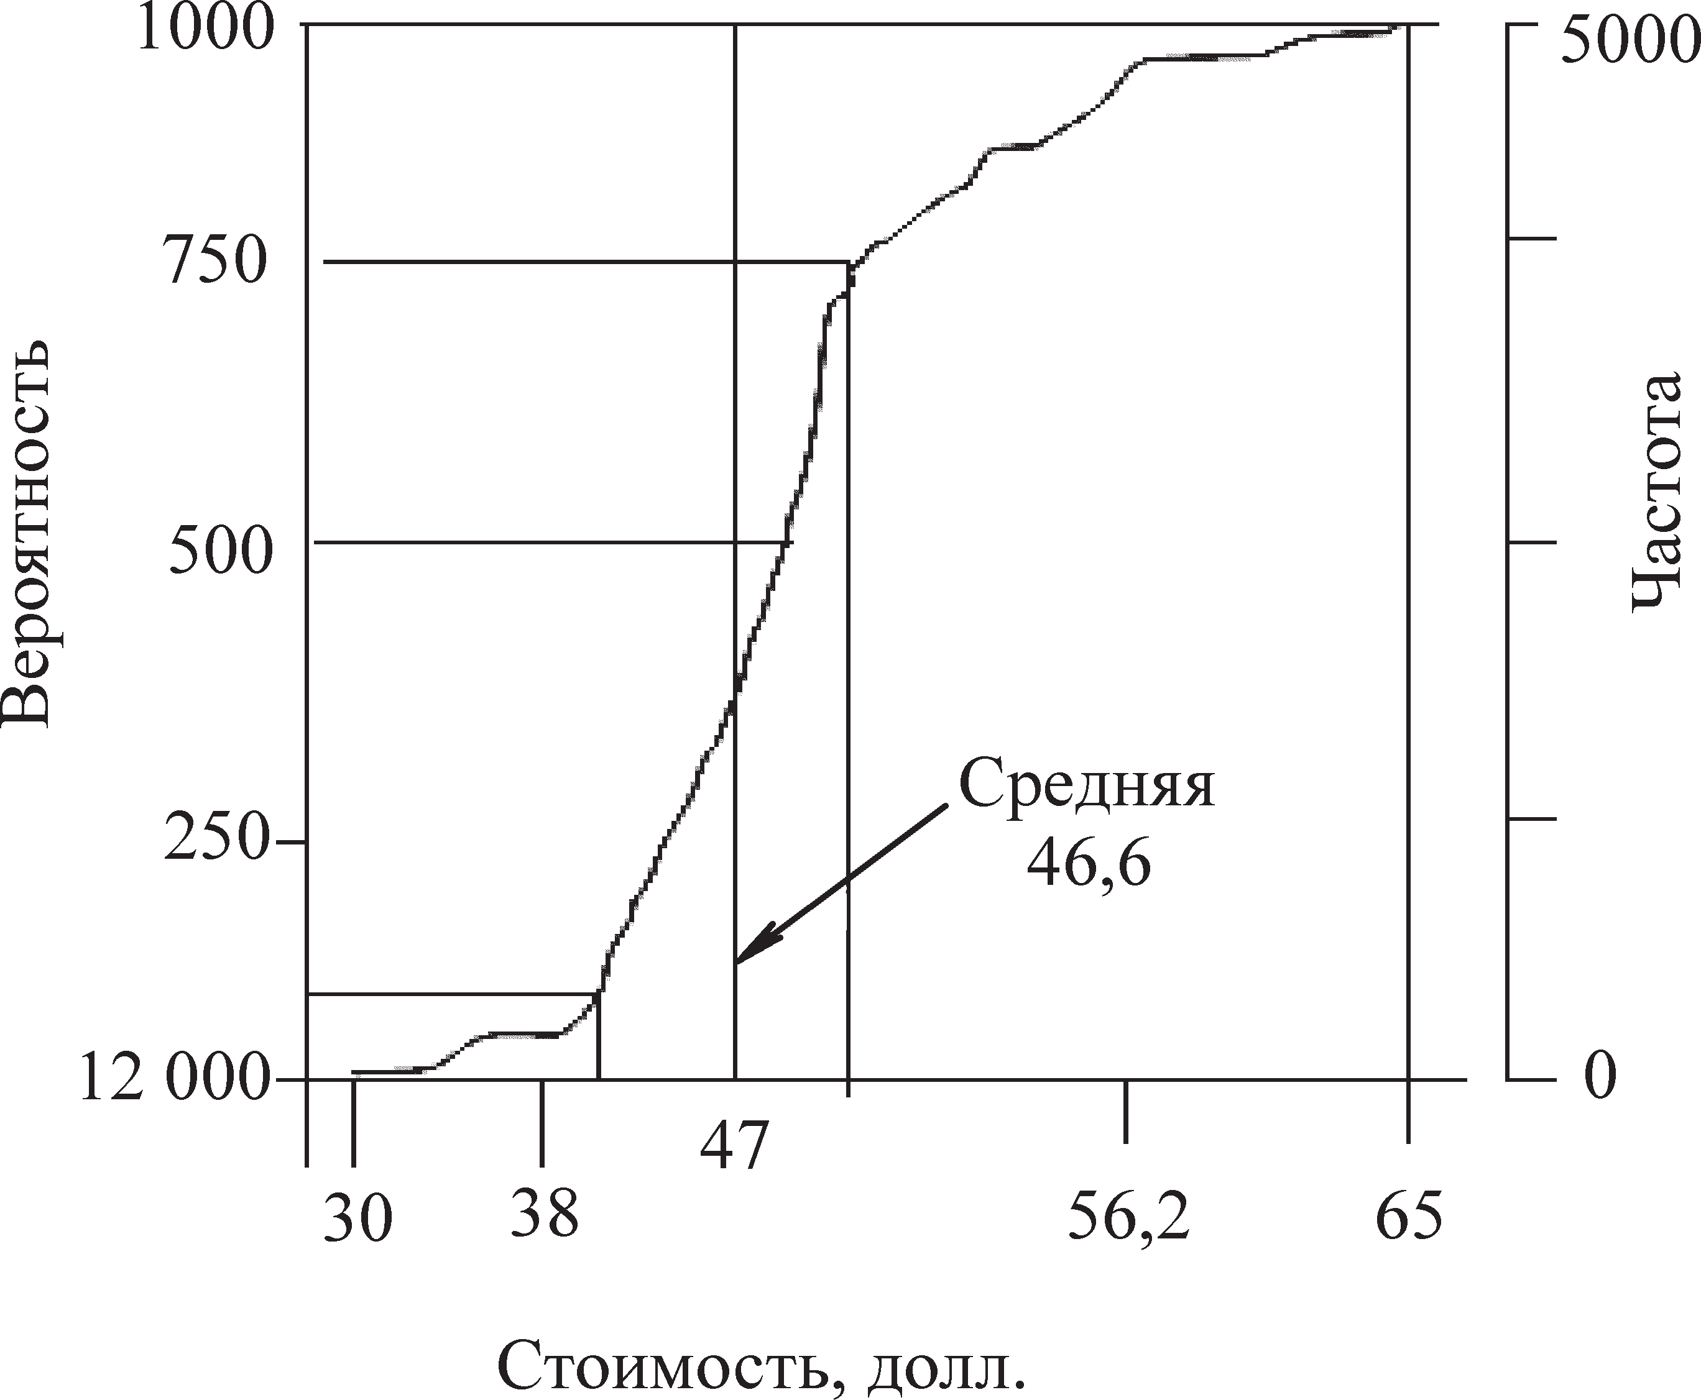

Process results:

- numerical assessment of the possible results of the project and their likelihood;

- assessment of the likelihood of achieving a specific goal or result of the project;

- finding realistic and achievable costs, timelines or results of the project;

- finding the best management solution with the uncertainty of some conditions or results.

Methods:

- sensitivity analysis;

- calculation of the break-even point;

- Monte Carlo method;

- PERT analysis;

- a method for constructing a decision tree (Table 14.4);

Algorithm of actions for quantitative risk analysis:

- Assessments are collected: pessimistic, optimistic, probable;

- a priori, the probability density of various outcomes is set (usually beta or triangular distribution);

- find quantitative risk assessments.

There are several strategies for responding to risks. For each risk, it is necessary to choose a strategy or a combination of different strategies that seems to be the most effective for dealing with it. to select the most appropriate way to respond to risks, you can use risk analysis tools (for example, a decision tree). Then it is necessary to develop specific measures for the implementation of the selected strategy.

Table 14.4

Quantitative analysis (decision tree)

|  |  |  |  |
| --- | --- | --- | --- |
| solution description | decision node | node of alternatives | path cost |
| decisions to be made | input: cost. output: accepted decision (yes, no) | input: probability of the scenario, income when it occurs. output: expected monetary gain (Expected Monetary | (result) - (cost) |

It is possible to define the main and reserve strategies. In case the chosen strategy does not work or turns out to be ineffective, as well as if an accepted risk arises, you can develop and use a contingency plan. There is often a contingency reserve in time and cost. Finally, contingency plans can be developed along with the definition of the conditions under which these plans are put into effect14.

Risk response planning is the process of developing risk response methods to increase the beneficial and reduce the adverse consequences of risk (Table 14.5).

The final document is the risk response plan.

A risk response plan may include:

- identified risks, their descriptions, project area affected by them (WBS element);

- results of qualitative and quantitative risk analysis, including a list of priority risks and probabilistic analysis of the project;

- strategies and methods for responding to risks;

- actions to implement the methods of response;

- the level of risk after the implementation of these actions;

Table 14.5

Risk response plan

Risk response strategies and methods

|  |  |  |  |
| --- | --- | --- | --- |
| avoidance | minimization | transfer | Adoption |
| - changing the project plan;  - rejection of unreliable partners;  - rejection of risky projects | -additional funding;  - increase in the number of resources;  — Reducing the scope of work or reducing requirements;  — development of a response plan for  consequences | - risk diversification (sharing risk with other participants or other programs / projects); | - preparation for the worst;  — reservation of funds |

- budget and work schedule required to minimize risks;

- emergency reserves in terms of time and cost to ensure stakeholder tolerance to risks;

- contingency plan;

- backlog plans to be used as a response to the emerging risk;

- residual risks that may persist after the response, as well as deliberately accepted risks;

- secondary risks arising from the response to the primary risk;

- emergency reserves formed as a result of the quantitative analysis of the project.

Diversification is the distribution of risks between project participants. distributing risks is an effective way to reduce them. It is more logical to make the project participant responsible for a specific risk who has the ability to more accurately and better calculate and control this risk. Risk allocation is formalized when developing a project management plan, financial plan and contract documents. It should be borne in mind that an increase in risks for one of the project participants should be accompanied by an adequate change in the distribution of project revenues. Therefore, when negotiating, it is necessary:

- to determine the capabilities of the project participants to prevent the consequences of the occurrence of risk events;

- to determine the degree of responsibility for the risk that each project participant takes on;

- agree on an acceptable risk reward.

Reservation - the creation of a reserve fund of financial resources to cover unforeseen expenses. Foreign project experience allows an increase in the cost of the project from 7 to 12% due to the reservation of funds for force majeure. Russian experts admit an increase in the cost of the project up to 20%.

Reserving not only increases project costs, but also increases project profits. Part of the reserve should be at the disposal of the project manager, the rest is managed in accordance with the contract by other project participants. Reserving funds provides for establishing a balance between the potential risks that change the cost of the project and the amount of costs associated with overcoming violations during its implementation. When calculating risks, it is necessary that the balance of accumulated real money in the financial plan of the project at each step of the calculation should be at least 8% of the costs planned at this step.

Risk insurance - transfer of certain risks to an insurance company. Depending on the chosen method of risk management, different sources of risk financing are distinguished:

- funds accounted for in the cost of products;

- own funds of enterprises, including the authorized capital and reserves formed from profit;

- external sources - loans, grants, loans;

- insurance funds;

- self-insurance funds.

14.5. Risks minimizing process

The process of minimizing risks is carried out according to the following algorithm:

- the risk that is of greatest importance to the project is considered;

- the cost overruns are determined taking into account the likelihood of an adverse event;

- a list of possible measures is drawn up to reduce the likelihood and danger of a risk event;

- additional costs for the implementation of the proposed activities are identified;

- the required costs for the implementation of the proposed measures are compared with a possible cost overrun due to the occurrence of a risk event;

- a decision is made on the implementation of anti-risk measures or refusal from them;

- the process of comparing the probability and consequences of risk events with the costs of measures to reduce them is repeated for the next most important risk.

Risk monitoring and management is the process of identifying, analyzing and planning emerging risks, tracking the identified risks and those that are listed for ongoing monitoring, and reviewing and executing risk response operations and assessing their effectiveness. Risk monitoring and management uses a variety of techniques, such as trend and variance analysis, which require performance data collected during project execution. Monitoring and managing risk is an ongoing process throughout the life of a project[17].

Risk monitoring is the process of observing existing risks, identifying new risks, and executing a risk response plan. Risk monitoring includes the following processes:

- revision of risks;

- risk audit;

- analysis of deviations and trends;

- technical measurement of performance;

- analysis of reserves;

- meetings on the current state.

Risk management is carried out at all phases of the project life cycle.

Stage 1. Pre-project feasibility study of investments, formulation of the project concept and its feasibility study. Risk analysis is carried out in the process of preliminary examination of the project. necessary actions of this stage:

- identification;

- risk analysis.

Stage 2. Planning of the project. work with risks is included in the development of the estimate and budget of the project. Necessary actions:

- correction of the decision tree;

- determination of the structure and volume of funds reservation;

- taking into account risks in the financial plan of the project.

Stage 3. Implementation of the project. work with risks is carried out in the monitoring process. Necessary actions:

- formation of the working budget of the project;

- risk insurance;

- control over the use of funds for unforeseen expenses;

- budget adjustments.

Stage 4. Completion of the project. work with risks is carried out at the stage of the final examination of the project. Necessary actions:

- analysis of the use of funds for unforeseen expenses;

- analysis and generalization of the actual manifestations of risks and uncertainties based on the results of the project.

15. PROJECT MONITORING AND ASSESSMENT OF THE PERFORMED PERFORMANCE

15.1. Project monitoring and its importance

15.2. Preliminary examination of the project

15.1. Project monitoring and its importance

Monitoring - constant observation of any process in order to identify its compliance with the desired result or initial assumptions, as well as observation, assessment and forecast of the state of the environment in connection with economic activities. Monitoring is a continuous feedback from the object to obtain information about the work done, the assessment of the project's effectiveness. It is conducted to oversee project processes related to initiating, planning, executing and closing a project. Monitoring is an aspect of project management and occurs throughout the project. May include collecting, measuring and disseminating information on project performance. Continuous monitoring allows the project management team to look inside the project and identify areas that require special attention. Monitoring is an assessment procedure carried out using a special technology, including:

- selection of evaluation criteria;

- selection of subjects of expert assessment;

- determination of methods for measuring the effectiveness of the project;

- development of tools;

- monitoring;

- analysis of the results obtained;

- expert conclusions and recommendations. types of expert assessment:

- preliminary examination of the project - this is an assessment of the effectiveness of the project at the stage of its planning;

- midpoint - an assessment of the effectiveness of the project in the process of its implementation in order to track intermediate results;

- final evaluation of the project - evaluation of the results of the project, its effectiveness.

The subjects of the assessment can be the project manager, members of the project team, the management of the organization, the customer, the investor, representatives of state and administrative structures, independent experts (specialists of the required profile and level).

Preliminary examination is carried out in several directions with appropriate evaluation criteria:

- examination of the preparation of the contract;

- systematic high-quality examination of the project;

- examination of the design solution;

Examination of contract preparation - determination of the feasibility and feasibility of the project based on the analysis of the terms and conditions of the contract prior to its signing by the customer.

Modern organizational theory identifies the following aspects of effectiveness:

- efficiency - efficiency, which is considered from the point of view of the ratio of costs and benefits;

- effectiveness - effectiveness, considered in terms of the relationship between goals and results.

The dual nature of efficiency gives rise to various models for evaluating and measuring project effectiveness:

1) cost - benefit - the ratio of the benefits received and the resources expended (efficiency criteria are economic indicators, profit, profitability, etc.);

2) cost - effectiveness - comparison of the total cost of the project (or individual activities) with the degree of achievement of the set goals;

3) approach from the point of view of shareholders (Stakeholders) - to assess the effectiveness of the project, different criteria are highlighted that correspond to the interests of stakeholders in the project:

- company owners - profitability, profitability;

- project team - job satisfaction, favorable social and psychological climate, remuneration;

- customers - quality of goods and services, low price;

- Suppliers - timely payment for deliveries;

- local communities - sponsorship, charity.

Systemic qualitative examination of the project - an assessment of the main structural positions of the project, identified at the stages of its life cycle. Criteria for evaluation:

- the relevance and validity of the problem, the correctness of its formulation;

- scope of the project - composition and structure of target groups;

- the presence of a strategic concept of the project;

- the logic of building the target structure;

- completeness of the presented resources, their analysis;

- the realism of the project (time planning);

- project manageability (team composition, management model and organizational structure of the project);

- economic efficiency of the project (estimate and budget of the project);

- project sustainability (project risks);

- expected results of the project, its social consequences;

- availability of project standards (main project documents).

15.2.Preliminary examination of the project

Expertise of a design solution - an assessment of the economic efficiency of a project, determination of the technical feasibility and reliability of the proposed solution, its compliance with the requirements and expectations of the customer.

Assessment of the economic efficiency of the project includes:

- method of net present value;

- a method based on taking into account the payback period of the project;

- method of net income;

- method of calculating the profitability ratio;

- method for calculating the financial marketability ratio.

Net present value method

Discounting is a way of determining the amount of future receipts in the present time estimate.

Economic calculation includes determining the amount of the discount:

D = a + b + c,

Where a is the price of capital without taking into account inflation or the profitability of alternative investment projects; b is the level of the risk premium for a specific project that satisfies the subject; с - inflation rate.

Net present value (NPV) is calculated as the difference between the accumulated discounted income from the project and the discounted one-time implementation costs. NPV corresponds to the Net Present Value (NPV) indicator, which is used in accordance with Western methods for assessing the economic efficiency of projects:

NPV = $\sum_{n=1}^{∞}{Di}$/( 1+d)n - Ki /( 1+d)n = (Di - Ki)/( 1+d)n

where Di is the income of the i-th period; Ki - costs of the i-th period; n is the number of project implementation periods; d - discount.

A project is cost-effective if NPV is positive. if it is necessary to choose one project from several presented, then preference should be given to the one where the NPV is greatest.

Payback based method

The payback period for a project is the period of time required to recover the initial investment by using the project's results. in other words, this is the time after which the NPV will take, according to calculations, a positive value. the payback period is calculated using equations for calculating NPD with an unknown period of implementation (x), and the value of NPD in this case is taken to be zero (discounted income is equal to discounted costs):

NPV = $\sum_{n=1}^{∞}{Di}$ (Di - Ki)/( 1+d)n



The payback period corresponds to the Payback period (PB) indicator. The project is economically efficient if the value of the payback period does not exceed the period of its implementation.

Determination of TB is necessary to confirm the correctness of the estimated volume of sales. (Tb) is calculated as the ratio of the equality of costs and proceeds from the sale of new products, services, etc.:

P • Tb = ν • Tb + C,

Tb = C ÷ (p - ν) = (C • N) (P - V) = (C • N) (M + C),

Where C is the conditionally fixed costs for the release of a new product or the implementation of an operation; p -is the price of a unit of production; Р - revenue from the sale of products, services, calculated for the period of production; v - variable costs of production; V - variable production costs for the period; M - profit for the period of implementation; N - annual output (sale) of products in kind.

tdc = total value (rp • cd) - investments,

Where rp is the annual profit from the project; cd - discounting coefficient.

Method of calculating the profitability ratio

The rate of return, sometimes called the ratio of income to costs, is the ratio of the present value to the amount of capital spent on a project.

If the coefficient exceeds 1.0, then the project is acceptable. The higher the value of the coefficient, the more profit the project promises.

Method of calculating the financial marketability ratio

Financial feasibility is another indicator used in the economic appraisal of projects. Financial feasibility is checked for the total capital of all project participants (including the state and all commercial participants, including creditors). Takes two meanings: "yes", "no".

Cash flows from each participant and the amount of revenue flows are “inflows” and are taken with a “+” sign. The cash flows coming to each participant from the project, and the costs of the project are called "outflows" and are taken with a "-" sign. If at each step of the calculation the sum of inflows and outflows is a positive value, the project is considered financially feasible.

Example

There is a project involving three commercial firms, two banks and a government that levies taxes. It is necessary to calculate the coefficient of financial feasibility of the project. the calculation scheme is given in table 15.1.

Table 15.1

Calculation scheme

|  |  |  |
| --- | --- | --- |
| № п/п | cash flow element name | values, units |
| 1 | Proceeds from sales (with vat, excise and duties) | +2100 |
| 2 | Production costs (with VAT for material costs spending) | –600 |
| 3 | Taxes received by the state | –500 |
| 4 | Firm flow 1 (the firm receives money at this step) | –600 |
| 5 | Firm flow 2 (the firm receives money at this step) | –700 |
| 6 | Firm flow 3 (the firm invests in this step) | +200 |
| 7 | Bank stream 1 (bank receipt of interest) | –100 |
| 8 | Bank flow 2 (issuance of a loan by the bank) | +300 |

Complex quantitative assessment of the project

The main indicator on the basis of which a choice is made in favor of a particular project is NPV. But this approach does not take into account the factors that determine the success of innovation. This significantly increases the risks of the project. According to American sources, it is possible to determine the main factors of success or failure of innovative projects, which are presented in table. 15.2.

Table 15.2

Key success factors

|  |  |  |
| --- | --- | --- |
| № п/п | Factor | weighted significance of the factor,% |
| 1 | Meeting the innovative needs of consumers | 26 |
| 2 | Favorable competitive environment | 10 |
| 3 | Compliance of innovation with the competence of the company | 19 |
| 4 | Technological superiority | 16 |
| 5 | Application of new production processes | 10 |
| 6 | Project management support | 14 |
| 7 | Organizational structure of innovation implementation | 5 |

Selection of a project without taking into account economic indicators

A project can be selected without taking into account quantitative indicators. in this case, the selection criteria may be:

- the ability of the project to resolve a crisis situation (in the event of force majeure);

- compliance of the project with legal requirements (when legal norms, laws, codes are mandatory, the problem of choosing a project and its implementation does not arise);

- meeting the social needs of employees (such projects are called social and are implemented in accordance with the company's human resources policy);

- ensuring a competitive advantage (if a project in conditions of intense competition can give an advantage to a company, it is necessary to quickly obtain permission for its implementation in order to enter the market earlier than competitors; such high-speed projects are not without risks that can be reduced by by the power of a feasibility study);

- immutable projects - arise under the influence of top management or family members and are not accompanied by the problem of choice.

Examination of the design solution, in addition to assessing the economic efficiency of the project, also presupposes the determination of the technical feasibility and reliability of the proposed design solution.

The degree of reliability and sustainability of the project is assessed taking into account the identification and analysis of project risks with the subsequent development of measures to minimize risks and their cost:

- plans are rarely 100% fulfilled;

- the actual execution of the project always differs from the planned one;

- the resulting deviations must be controlled.

Median score

Control processes are subdivided:

- general control of changes: tracking and coordination of changes in the project as a whole;

- control of project reporting: collection and transmission of information on the progress of the project, including reports on work performed, implementation of planned targets, forecast taking into account the available results;

- control of changes in the content: control over changes in the scope of the project;

- schedule control: control over the implementation of the project;

- cost control: control of costs for work and changes in the project budget;

- quality control: tracking specific project results to determine their compliance with established standards and taking the necessary measures to eliminate the causes leading to a decrease in the quality of work and product;

- risk control - responding to changes in the level of risk during the implementation of the project.

Final project evaluation

This assessment presupposes a full comprehensive assessment of the final results of the project in all its aspects, primarily from the point of view of the most important indicators:

* terms, costs, results; to what extent the actual costs received correspond to the planned ones;
* to what extent the planned dates coincide with the actual ones;
* to what extent completeness coincide with the intended results of the project.

The overall effect of the project is assessed from the point of view of various actors - both project users, the project team, and project participants.

TOPIC 16. CHANGE MANAGEMENT AND PROJECT COMPLETION

16.1. Change management

16.2. Completion of the project

16.1. Change management

Control processes are closely related to each other and can be presented, if necessary, as a single process called “change management”.

Changes are the replacement of a management decision due to the impact of various objective or subjective factors in the development and implementation of a project. Changes can be made in various sections of the project and at any stage of the project life cycle. Their initiator can be any project participant, most often it is the customer (can change the final characteristics of the project), the developer (can change the original documentation), the contractor (changes in technology, plan, methods of work).

Reasons for possible changes:

- randomness in design decisions;

- improvement of tools, methods, materials;

- lagging behind the schedule;

- changes in prices.

Types of changes can be divided into internal and external. Internal changes depend on the parameters of the project itself: terms, deliveries, schedules, financing, etc. External ones are carried out at the macro level: politics, law, economics, technical progress, etc. and do not depend on the project in any way. The impact of changes on the project - both internal and external - can vary in a very wide range - from global to insignificant. All changes in the project ultimately affect the “magic triangle of the project”: additional costs arise, the terms and quality of work change.

Change management includes the following procedures:

- tracking - collecting and documenting factual data; determination in official and unofficial reports of the degree of compliance of the actual performance with the planned indicators; data collection is carried out on such indicators as time, cost, quality, project organization, content of work;

- analysis - assessment of the current state of work and comparison of the achieved results with the planned ones; determination of the causes and ways of influencing deviations from the plan;

- adjustment - planning and implementation of actions aimed at performing work in accordance with the plan, minimizing unfavorable deviations or obtaining benefits from the occurrence of favorable situations.

Thus, it can be stated that change management should be carried out systematically and sequentially according to a certain algorithm, which includes several successive stages, in particular, forecasting and planning future changes; systematization of all changes to study and assess the consequences; acceptance or rejection of changes; organization of monitoring; synchronization of enforcement efforts, etc. change management is carried out in accordance with a standard algorithm and is documented. The standard change management algorithm includes several stages:

1. Fixation of the basic state of the system. This is a description of the configuration of the current parameters of the project as a set of technical documentation at a given time.

2. Forecasting changes. is carried out at all stages of the life cycle, special attention is paid to important "milestones" of the project, in which there is a high probability of "branching" of possible project scenarios, tasks with a high degree of risk, critical tasks, etc. At the stage of project development to ensure possible changes, variations of the scenario are laid down physical and price reserves.

3. Assessment of the proposed changes. This is a comprehensive analysis of the impact of the change on the project cost, performance indicators, network schedules and the final result of the project. When performing this procedure, various methods of analysis are used: functional-cost, analysis of alternatives, methods of analyzing the network diagram, etc.

4. Changes are reviewed by the project team or ad hoc committee. it is sometimes called a change management committee. Committee functions can be performed by an existing management unit (or several units).

The committee is considering significant changes:

- in the content;

- basic plan;

- cost;

- timing.

Changes can be considered by a conciliation commission, which consists of the leading specialists of the organization. all changes must go through the approval procedure. Decision-making levels depend on the scale and consequences of the changes being made. Compliance with their level of decision-making is reflected in table. 16.1.

Table 16.1

Decision-making levels

|  |  |  |  |
| --- | --- | --- | --- |
| Nature of the change / who approves | Project Manager | Project curator | Board of Directors |
| general budget  budget for individual sectors | —  deviations in size no more than 10% | —  deviations in size no more than 20% | any deviations in the amount of the total budget  — |
| прибыль про- project profit | — | Deviations by profit 10 % | profit deviation more than 10% |
| transfer of dividends | — | — | any dividend variance |
| project results | — | — | change in the expected results of the project |
| project goals | — | — | changing goals  and project objectives  change in project duration by more than 3  months |
| project duration | Change the duration of activities without affecting the duration of the project (not on the critical path) change the duration of activities without affecting the duration of the phase (not on the critical path) | change in total  project duration  within 0.5–1 month |  |
| duration of a separate phase of the project | changing the duration of operations without affecting the duration of the phase (not on the critical path) | change  duration  phases within 1–2 weeks | — |

After considering the necessary proposals, a verdict may be issued:

- to approve;

- refuse;

- postpone;

- modify;

- escalate.

5. Implementation of changes. the project manager, who has received the consent of the committee to implement the changes, must update the project documentation, inform all departments of the organization participating in the project, notify the cooperating entities, project participants, and develop the necessary measures to implement the changes.

The approximate form of the final document for the approval of changes is given in table 16.2.

Table 16.2

Documenting decisions about changes

|  |  |
| --- | --- |
| Change description | Analysis of the type of change and its consequences |
| Change request number |  |
| Heading |  |
| A priority | High - a mandatory change, there are no other alternatives.  Medium - mandatory or highly desirable change, but alternatives are available.  Low - not mandatory, but a desirable solution for improving the project |
| Initiator information | |
| Detailed description of the change | If necessary, it is possible to use an appendix to describe the change |
| Reasons for the need for change | |
| The impact of the change on the project | |
| Decision of the project manager upon request for change: signature,  date | Solution:  - accept - make the proposed change;  - to cancel - to recognize as inexpedient to give a course to this request;  - postpone - the request makes sense, but it will  reviewed at a later stage;  - to conduct an assessment - the request makes sense and it is necessary to conduct an analysis and assessment of the consequences;  escalate - the request makes sense, but only the higher-level committees have the authority to assess and make decisions |
| Decision of the curator of the project: signature, date | |
| Assessment of the consequences of the change and recommendations (made by an expert committee) | A list of subprojects that will be affected by the change.  influence on the duration of the plan in days by subprojects.  Influence on the scope of work of the project by subprojects.  Impact on the cost of the project by subprojects. final grade (if possible) |
| Decision of the board: signature, date | |

6. Monitoring the implementation of changes. control is reduced to continuous monitoring of the state of the system, taking into account the changes made. in practice, this looks like a comparison of actual changes with planned ones. special attention is paid to the impact of the changes made on the project timeline, the use of resources and the cost of the project.

If the project has a large number of changes or they are large-scale, or are too important for the final goals of the project, then in large-scale projects with matrix organizational structures, separate divisions can be formed to implement changes and monitor their implementation.

16.2. Completion of the project

Completion of the project involves the implementation of all formal procedures stipulated by the standard for the legal transfer of the project documentation to the user after the completion of all project tasks and achievement of all goals. thus, the completion of the project presupposes both the completion of all project tasks and the resolution of all controversial issues, the execution of the project documentation and its delivery to the archive. Standard stages of project completion are shown in Fig. 16.1.

|  |  |  |  |  |
| --- | --- | --- | --- | --- |
|  |  |  |  | **Acceptance certificate** |
|  |  |  |  |  |
|  |  |  |  | **Protocol** |
|  |  |  |  |  |
| **From control's processes** |  | **Administrative closure** |  | **Lessons learned** |
|  |  |  |  |  |
|  |  | **Closing contracts** |  | **Completion Order** |
|  |  |  |  |  |
|  |  |  |  | **Project archive** |

Figure. 16.1. Project completion process diagram

Project completion includes the following processes:

1.Close project domain management:

a) drawing up a summary report based on the analysis of project results;

b) resolution of controversial and conflict situations;

c) formation of the project archive.

2.Closing the project by the time parameters of the project:

a) drawing up a report based on the analysis of the implementation of the project deadlines;

b) the formation of an archive of calendar plans.

3. Closure of the project for the cost and finance of the project: a) economic analysis and evaluation of results;

b) resolution of claims and conflicts on the part of the customer, investor and other project participants;

c) preparation of executive estimates and financial statements; d) final settlement and closing of financing;

e) formation of an archive of financial documents.

4.Closing the project by the quality of the project:

a) a summary assessment of the quality of the project results; b) decision on final acceptance;

c) a list of comments and quality claims;

d) resolution of controversial issues and quality conflicts;

e) preparation of documentation and archive for quality management.

5.Closing a project for project risks:

a) analysis and generalization of actual data on the manifestation of risks and uncertainties in the project;

b) analysis of the implementation of risk management plans;

c) preparation of a consolidated final risk management report.

6.Close the project by project personnel:

a) analysis and evaluation of the activities of the project team; b) conflict resolution;

c) carrying out the final calculation of personnel; d) formation of the archive of the project team;

e) disbandment of the project team.

7.Close the project on project communications:

a) the final report on the management of communications in the project;

b) formation of an archive of project documentation;

c) making a decision on the further use of the communication means of the project.

8. Closure of the project for changes in the project:

a) assessment of the changes and their results;

b) a final report on the actual changes to the project;

c) formation of an archive of project changes.

Effective forms of early completion of the project:

- refusal to implement the project before the start of construction and installation work;

- sale of a partially realized project in the form of an object of construction in progress;

- sale of a product at the stage of its operation;

- attraction of additional share capital at any stage of the project implementation with minimization of its share participation;

- separate sale of the main types of assets of the project being implemented.

LIST OF RECOMMENDED LITERATURE

The main:

The Deadline: A Novel About Project Management: 9780932633392: Tom DeMarco: Books.

Дульзон A. A . Управление проектами : учеб. пособие / а. А. Дульзон; Нац. исслед. Том. политехн. ун-т. 3-е изд., перераб. и доп. Toмск : изд-во Том. политехн. ун-та, 2010. 334 с.

Мазур И. И. Управление проектами / и. и. Мазур, В. Д. Шапиро, н. Г. Ольдерроге. М. : Экономика, 2003. 245 с.

Попов Ю. И. Управление проектами : учеб. пособие для слушателей образовательных учреждений / Ю. И. Попов. М. : ИНФРА-М , 2010. 208 с.

Фунтов В. Н. Основы управления проектами в компании : учеб. по- собие по дисциплине, специализации, специальности «Менеджмент организации» / в. н. ФУНТОВ. СПБ. : ПИТЕР , 2011. 394 с.

Biafore B. Microsoft Project. 2013 / B. Biafore. The Missing Manual PDF O'Reilly Media. 2013.812 p.

Campbell C. A. The One-Page Project Manager for Execution: Drive Strategy and Solve / C. A. Campbell, M. Campbell // Problems with a Single Sheet of Paper PDF Wiley. 2nd ed. 2012.210 p.

Project management. A Guide to the Project ManagementBody of Knowledge: PMBOK guide. 3rd ed. 2004.506 p. [Electronic resource]. URL: http://rutracker.org/forum/viewtopic.php?t=2831128

Additional

Ивасенко А. Г. управление проектами : учеб. пособие для студентов / А.Г.Ивасенко. ростов н/д : Феникс, 2009. 330 с.

PMSOFT conferences on project management // problems of theory and practice of management. 2011. No. 7. p. 102.

*Кузнецов А. А.* Процессное управление проектами на предприятии / А.А. Кузнецов // Менеджмент сегодня. 2011. № 4. с. 206–212.

*Куперштейн В.* Microsoft Project 2010 в управлении проектами / В. Куперштейн. СПб.: БХВ-Петербург, 2011. 416 с.

*Лапыгин Ю. Н.* Оценка эффективности проектного управления / Ю. Н. Лапыгин // Экономический анализ : теория и практика. 2011. № 15. с. 50–53.

*Мазур И. И.* Управление инвестиционно-строительными проектами: международный подход / И.И. Мазур. М. : омега-л, 2011. 736 с.

*Матвеева Л. Г.* Управление проектами : учебник / Л.Г. Матвеева. Ростов н/д : Феникс, 2009. 423 с.

*Мыльников Л. А.* Микроэкономические проблемы управления инновационными проектами / Л.А. Мыльников // Проблемы управления. 2011. № 3. с. 2–11.

*Озерова Т.* Системная триада как основа управления проектами на предприятиях общественного питания / Т. Озерова // риск : ресурсы, ин- формация, снабжение, конкуренция. 2011. № 2, ч. 1. с. 35–38.

*Пигалов В.* Секреты успешного управления проектной командой / В. Пигалов // БОСС : бизнес, организация, стратегия, системы. 2011. № 7. с. 64–65.

*Романова М. В.* Управление проектами : учеб. пособие / М.В. Романова. М.:ФОРУМ:ИНФРА-М , 2010. 253 с.

*Туккель И. Л.* Управление инновационными проектами : учебник для студентов высших учебных заведений, обучающихся по направлению подготовки «инноватика» / И.Л. Туккель. СПб. : БХВ-Петербург, 2011. 396 с.

1. Project management. A Guide to the Project Management Body of Knowledge:PMBOК guide. 3rd ed. 2004. P. 3 (далее PMI PMBоK. 2004).
2. Lukov V. A. social design: textbook. allowance. M., 2003. p. 39–46.(*Луков В. А.* социальное проектирование : учеб. пособие. М., 2003. с. 39–46.)
3. Mazur, I.I., Shapiro V.D., Olderogge N.G. Project management / ed. ed. prof. and. and. Mazura. M., 2001. C. 312.
4. PMI PMBоK. 2004. р. 112.
5. WBS (Work Breakdown Structure) — структура разбиения (декомпозиция) работ
6. PMI PMBOK. 2004. Russian edition. with. 171.
7. Mazur I.I., Shapiro V.D., Olderogge N.G. project management / ed. ed. prof. and. and. Mazura. M., 2001.
8. 3 PMI PMBоK. 2004.
9. 4 PMI PMBоK. 2004. p. 181
10. Mazur I.I., Shapiro V.D., Olderogge N.G. Project management. p. 473.
11. Mazur I.I., Shapiro V.D., Olderogge N.G. Project management. p. 473.
12. Краткий словарь современных понятий и терминов. М., 1993. с. 140.
13. PMI PMBоK. 2004. p. 228.
14. PMI PMBоK. 2004. p. 242
15. PMI PMBоK. 2004. p. 242
16. PMI PMBоK. 2004. p. 249
17. PMI PMBоK. 2004. p. 264